OBJECTIVE
To develop an efficient and accurate computational model for heart disease risk prediction using a Dual State Stacked Machine Learning approach, aiming to enhance early diagnosis and preventive healthcare by combining multiple learning states for improved performance.
MOTIVATION
Heart disease remains one of the leading causes of death globally. Early prediction of heart disease risk can significantly reduce mortality through timely intervention and treatment. Traditional statistical and single-layered machine learning models often struggle with capturing complex nonlinear relationships in medical data. Therefore, a more robust and layered learning model — such as a Dual State Stacked Machine — can potentially improve prediction accuracy, computational efficiency, and interpretability. This approach not only leverages the strengths of ensemble learning but also introduces a dual-state mechanism to enhance feature learning, reduce overfitting, and optimize computational performance. By providing more reliable risk assessments, this model could assist healthcare professionals in making informed decisions and personalizing patient care.
PROBLEM STATEMENT
Despite numerous advances in machine learning-based models for heart disease prediction, existing systems often face challenges in achieving high accuracy, generalizability, and efficiency when processing heterogeneous and high-dimensional medical datasets. Many models suffer from overfitting, slow convergence, or lack of interpretability.
This research proposes the design and implementation of an Efficient Computation Risk Prediction Model for heart disease based on a Dual State Stacked Machine architecture. The goal is to:
- Integrate two distinct learning states for layered feature processing.
- Enhance classification accuracy by reducing noise and improving decision boundaries.
- Optimize computational cost while maintaining robustness and scalability.
The proposed model aims to outperform traditional models in terms of accuracy, training time, and predictive reliability, thereby contributing to more effective early detection strategies for heart disease.
ABSTRACT
Cardiovascular diseases (CVDs) continue to be a prominent cause of global mortality, necessitating the development of effective risk prediction models to combat the rise in heart disease (HD) mortality rates. This work presents a novel dual-stage stacked machine learning (ML) based computational risk prediction model for cardiac disorders. Leveraging a dataset that includes eleven significant characteristics from 1190 patients from five distinct sources, five ML classifiers are utilized to create the initial prediction model. To ensure robustness and generalizability, the classifiers are cross-validated ten times. The model performance is optimized by employing two hyperparameter tuning approaches: RandomizedSearchCV and GridSearchCV. These methods aim to find the optimal estimator values. The highest-performing models, specifically Random Forest, Extreme Gradient Boost, and Decision Tree undergo additional refinement using a stacking ensemble technique. The stacking model, which leverages the capabilities of the three models, attains a remarkable accuracy rate of 96%, a recall value of 0.98, and a ROC-AUC score of 0.96. Notably, the rate of false-negative results is below 1%, demonstrating a high level of accuracy and a non-overfitted model. To evaluate the model’s stability and repeatability, a comparable dataset consisting of 1000 occurrences is employed. The model consistently achieves an accuracy of 96.88% under identical experimental settings. This highlights the strength and dependability of the suggested computer model for predicting the risk of cardiac illnesses. The outcomes indicate that employing this two-step stacking ML method shows potential for prompt and precise diagnosis, hence aiding the worldwide endeavor to decrease fatalities caused by heart disease.

CHAPTER-1
INTRODUCTION
The major essential organ – the heart, whose main function is to move the blood throughout our body, but having a threat to it is a matter of concern that causes several health issues. Heart disease (HD) is contributing the leading cause of death due to sudden strokes and heart attacks in today’s world. Every year, 17.9 million people die from some causes related to CVD, and a total of 32% of all deaths are estimated globally [1]. The most common type of HD that contributes to major deaths worldwide is coronary heart disease (CHD). There are various forms of heart disease, namely problems related to heart rhythms, valves, heart muscles, heart infection, blood vessel disease, and congenital heart defects. Because of these different forms, several symptoms can be observed: dizziness, fainting, slow heartbeat, racing heartbeat, shortness of breath, etc. While heart disease can be deadly, it can also be prevented by adopting a healthy lifestyle like regular meditation, regular exercise, a nutritious diet, etc. In identifying modern healthcare-related diseases, machine learning (ML) and deep learning (DL) play an important role, including properly detecting and classifying these kinds of ailments. The cost of curing heart disease is very high worldwide and may exceed $1 trillion by 2035 [2]. In the United States, about $229 billion was spent annually between 2017 and 2018 [3]. Hence, the minimization of the treatment cost for HD has become extremely important. For this purpose, many researchers have applied classical ML approaches [4], [5], and [6] based on characteristic features to determine if a patient can suffer from HD. The dataset [7] used in this research study contains 11 important features, one target outcome indicates whether patients had a risk of HD or not, and 1190 instances with which we trained five well-known classical ML models, namely Logistic Regression (LR), Support Vector Machine (SVM), Random Forest (RF), Decision Tree (DT), and Extreme Gradient Boost (XGB), along with an ensemble-based stacking technique to gain higher results in performance metrics The conventional ML model is considered for detecting HD and provides a prediction model that is more stable and accurate. We used k-fold cross-validation (CV) to properly split the acquired dataset into training, testing, and validation. Next, we trained the above-mentioned standalone models with and without hyper-parameter tuning by the RandomizedSearchCV (RS-CV) and GridSearchCV (GS-CV) and selected the best three models, namely DT, RF, and XGB, corresponding to their RS-CV technique predicted accuracy, and performed the ensemble stacking operation with the hold-out testing set, and achieved an accuracy (Acc), Precision (Pr), Recall (Re), F1-score (Fs), ROC-AUC (Ra) score, and Cohen-cappa score (Cs) of 96%, 0.96, 0.98, 0.96, 0.96 and 0.92 respectively. To validate the HD risk prediction model, a similar dataset was collected from the Mendeley data portal with 1000 instances and 12 features replicated the above procedure on it, and was used to check the stability and robustness of the deployed model with the accuracy of 96.88% and a lower standard deviation.
1.2. LITERATURE REVIEW
The study titled "An Efficient Computational Risk Prediction Model of Heart Diseases Based on Dual-Stage Stacked Machine Learning Approaches" presents a novel ensemble learning framework aimed at enhancing the accuracy and reliability of heart disease risk prediction. This literature review outlines the key components, methodologies, and findings of the study, situating it within the broader context of existing research in the field.
Overview of the Proposed Model
The study introduces a dual-stage stacked ensemble model that integrates multiple machine learning classifiers to predict heart disease risk. The approach involves:Journal UMY+1MDPI+1
- Data Collection and Preprocessing: Utilizing a dataset comprising 1,190 patient records from five distinct sources, the study selects eleven significant features pertinent to heart disease.Journal UMY+3AB Technologies+3Directory of Open Access Journals+3
- First Stage - Base Learners: Five machine learning classifiers—Random Forest, Extreme Gradient Boosting (XGBoost), Decision Tree, Support Vector Machine, and Logistic Regression—are trained using ten-fold cross-validation to ensure robustness and generalizability.AB Technologies
- Hyperparameter Tuning: Employing RandomizedSearchCV and GridSearchCV techniques to optimize the performance of the base classifiers.Directory of Open Access Journals+1AB Technologies+1
- Second Stage - Meta Learner: The top-performing models (Random Forest, XGBoost, and Decision Tree) are further refined using a stacking ensemble technique, where their outputs serve as inputs to a meta-classifier, enhancing predictive performance.ResearchGate+2AB Technologies+2Directory of Open Access Journals+2
- Model Evaluation: The final stacked model achieves an impressive accuracy of 96%, a recall of 0.98, and an AUC score of 0.96, with a false-negative rate below 1%, indicating high precision and reliability .Directory of Open Access Journals
Contextualizing Within Existing Literature
The proposed dual-stage stacking approach aligns with and advances current research trends in heart disease prediction using ensemble learning methods.
- Stacked Ensemble Models: Previous studies have demonstrated the efficacy of stacking ensemble techniques in improving classification performance for heart disease prediction. For instance, a study achieved a 95% accuracy using a combination of base classifiers enhanced by boosting techniques .ResearchGate+1MDPI+1
- Feature Selection Methods: Incorporating feature selection methods, such as the chi-square technique, has been shown to enhance model accuracy by focusing on the most relevant features, thereby reducing dimensionality and improving computational efficiency .Journal UMY
- Explainable AI: The integration of explainable AI techniques, like SHAP (SHapley Additive exPlanations), in ensemble models has facilitated better interpretation of model predictions, aiding in clinical decision-making processes .MDPI
Significance and Future Directions
The dual-stage stacked ensemble model presents a significant advancement in heart disease risk prediction by combining multiple classifiers and optimizing their performance through rigorous validation and tuning. Its high accuracy and low false-negative rate underscore its potential utility in clinical settings for early and reliable diagnosis.Journal UMY
Future research could explore the integration of deep learning models, such as CNN-LSTM hybrids, to capture complex patterns in patient data, potentially further enhancing predictive accuracy . Additionally, expanding the dataset to include more diverse populations and incorporating real-time data could improve the model's generalizability and applicability in various healthcare contexts.MDPI
The related kinds of literature are discussed in this section, considering ML-based prediction or detection models of HD. The entire literature is subdivided into a few sections related to the approaches, like ensemble-based ML prediction models, standalone different ML models, and reduced feature-based HD prediction and classification models. This section mainly focuses on ensemble-based approaches like the one proposed by the authors in [8] to predict the risk of HD on the Cleveland dataset (CD). A few base models were used for initial prediction, like Naive Bayes (NB), RF, Bayes Net (BN), C4.5, Multi-Layer Perception (MLP), and PART (Projective Adaptive Resonance Theory). Four ensemble approaches were used for the final prediction, including bagging, boosting, and stacking, and results were claimed by the BN, RF, NB, and MLP based on voting. Features were considered in the selected way for each model evaluation. The claimed results were 85.48%, with increased accuracy on chosen features. In [9], the authors deployed the HD prediction model on the famous CD using an AI approach based on the digital history of patients’ records. The algorithms used were DT, Artificial Neural Network (ANN), Rough Set (RS), SVM, and NB. The ten-fold CV was considered to calculate the mean accuracy with the RS, which gave an accuracy of 88.1%. The authors then proposed an ensemble method wherein they combined the top 3 performing algorithms, namely RS, NN, and NB, to improve the performance to 89%, outperforming all other classifiers. The authors in [10] chose the CD for the HD prediction model, which contained 76 attributes that were reduced to 13 significant features and one target attribute. Four different algorithms were applied: Stochastic Gradient Descent (SGD), K-Nearest Neighbor (KNN), LR, and RF. Finally, an ensemble method was proposed by combining all four models using hard voting. Amongst the four algorithms, SGD gave the highest accuracy of 88% after hyperparameter tuning, and the model concludes with the best accuracy of 90%. Also, in [11], the authors presented the classical AI approach to predict heart disease early using three ML algorithms: RF, DT, and a proposed hybrid model. The CD was used to deploy the model, with 70% of the dataset taken for training and the rest, 30% for testing. The proposed hybrid model combined with RF and DT gave an Acc of 88%. In [12], they explored the use of ML and DL classifiers to provide an early detection system for HD. The CD was taken, and LR, SVM, KNN, NB, ANN, DT, the Back Propagation Neural Network (BPNN), and ensemble-based stacking, boosting, and bagging were applied to increase the models’ Acc. SVM gave an accuracy of 86% using all features and an accuracy of 88% using selected features. The proposed ensemble algorithm reaches an Acc of 92.30% and a BPNN of 93%. They considered in [13] the various ML techniques for large-scale heart disease prediction based on big data analysis. The widely used Cleveland dataset was used to split in a 0.90:0.10 ratio. Different algorithms were applied: DT, RF, LR KNN, SVM, AdaBoost (AB), Gradient Boost (GB), DT, HRFLM, and HGBDTLR. The proposed ensemble algorithm HGBDTLR gave the best accuracy of 91.8%. In [14], the authors proposed an ensemble technique based on the Classification and Regression Tree (CART) for HD risk prediction. Two datasets were taken and split into random numbers based on mean values. The different CART models faded into a homogenous ensemble classifier, and accuracy was weighted. Their experimental results showed an accuracy of 93% on the CD. They compared their results with the performances of the SVM, RF, LR, Linear Discriminant Analysis (LDA), GB, and KNN models. Moreover, the article [15] used the CD to predict heart diseases using various ML algorithms, namely KNN, RF, NB, SVM, XGB, and LR, which were applied, and an observatory analysis was drawn. Several evaluation metrics were taken for the performance acumen evaluation of every model. Among these, a proposed ensemble method based on voting and combining three algorithms, namely KNN, XGB, and LR, gave the best accuracy of 92%. In [4], the author uses three datasets to train a custom-based ensemble classifier consisting of NB, RF, SVM, and XGB with parameter tuning. The data has been trained on a 0.60:0.40 ratio of training to testing, and underfitting is also taken care of by using such a division. The prediction made by the classifier is put to the test on one of the datasets provided with the help of a voting classifier. The highest accuracy achieved by the model is 96.75% with the Mendeley dataset using the proposed model, while the other two datasets also give results of 88.24% and 93.39%, respectively. In [5], the authors extracted features from recording the magnetocardiography (MCG) signal, used 164 features categorized into three subgroups, and developed a fast model to detect ischemic heart disease. The four ML models were used to compare the results, like KNN, DT, SVM, and XGB; after that, finally, the ensemble method was applied, combining two SVM and XGB models to get the best results with 94.03% accuracy and an AUC value of 0.98. The subsection below considered different ML models for HD prediction compared their observable experimental outcomes and concluded their research with a particular ML model. Like in [16], the authors used an open-source dataset for predicting heart diseases. They incorporated five different ML algorithms for training the dataset: KNN, DT, RF, NB, and SVM. Metrics like Acc, specificity, and Re were used to conclude the performance acumen of the model. Amongst these, KNN had the best accuracy, at 85%. The authors in [17] deployed five ML algorithms to classify CVD: SVM, NB, KNN, DT, and LR. An open-source dataset with 77,000 instances was used to make the prediction models. Performance metrics like Re, Pr, Acc, and Fs were measured to analyze the models. LR and SVM observed efficient algorithms for diagnosing CVD anomalies with accuracies of 72.66% and 72.36%, respectively. The article [18] explored using ML models to predict CVD early at low and affordable costs. Various algorithms like NB, DT, RF, KNN, SVM, and LR were incorporated to predict the CVD. The CD was taken for model prediction, concluded with measuring parameters to acumen, and the RF had the highest Acc of 83.52%. In [19], authors had laid down an approach to predict heart diseases with the greatest accuracy and consuming less time for computation so that diagnosis of the disease is at the earliest. The popular CD was used to train and test models like LR, KNN, DT, and RF. Amongst these, RF gave the best accuracy of 88.16%, followed by LR with an accuracy of 84.21%. The authors in the article [20] considered a heart disease dataset to predict and deploy six ML models: LR, AB, KNN, CART, XGB, and RF. After data processing, ten-fold cross-validation was applied with hyperparameter tuning of the above model’s parameters. Their claimed results were accurate, and the ROC-AUC values are 84.8% and 0.917 for the RF model. In [21], the authors used different supervised ML models to predict heart diseases. The dataset used in their study contains 14 attributes and 303 instances in total. Algorithms like LR, KNN, and SVM were incorporated, and these models’ efficacies were judged on metrics like Re, Pr, specificity, Fs, and Ra. Overall, LR performed well, with an accuracy of 86%, a precision of 0.83, and an AUC score of 0.87. The authors in [22] presented an approach for the future possibility of HD using ML models like RF, NB, SVM, Hoeffding DT, and Logistic Model Tree (LMT). The CD was incorporated for training the models. RF and Gaussian-NB performed considerably well, with accuracies of 95.08% and 93.44%, respectively. In [6], the CART algorithm predicts the HD and extracts the decision rule to find the relationship between the target class and the inputs. It provides an influencing feature-based ML model with an accuracy of 87.25% over the dataset of 1190 instances and 11 features Some related works have been observed on the feature selection-based approaches; the authors in [23] presented the KNN model as the base method for predicting cardiovascular diseases. The famous CD dataset was incorporated for this work. However, KNN alone could not achieve significant results, so the authors utilized techniques like standardization, feature selection, and cross-validation to increase the method’s accuracy. Fourteen important features out of 75 total attributes were used in the process. The ten-fold CV was used to measure the mean Acc, 89.23%. In [24], the two ML models, LR and ANN, were considered for predicting HD using the CD. Eleven significant features out of 75 were considered for the process. Variable hidden layers and other activation functions were applied for further tuning these models. ANN with one hidden layer and the sigmoid function gave an Acc of 92.31% and an LR of 90.11%. The authors in [25] explored the data mining approach for identifying meaningful patterns from HD datasets. For this purpose, they used the CD, wherein six ML algorithms were applied, namely NB, DT, LR, RF, KNN, and SVM, after applying Information Gain, Chi-Square, Gain Ratio, RELIEF, and One-R. Amongst these, SVM gave the best accuracy of 83.41% after applying the feature selection method. In [26], the authors used AI in the healthcare sector to predict heart diseases and other locomotive disorders. They used the CD, which consisted of 76 features and 303 instances, among which 14 important attributes were chosen for the prediction model. A ten-fold CV was used to measure the mean accuracy of the deployed models. In addition, performance indicators like Acc, Re, Pr, Fs, and Ra were calculated to measure results acumen. The SVM, LR, NB, DT, KNN, and RF models were deployed, and, among them, KNN gave the highest accuracy of 94.1% using seven significant features. The above-related literature study is considered mainly for predicting HD using conventional ML models with the specific motivation of resource-constrained devices’ perspective use of less memory and a significantly shorter response time. ML models are less complex and more effective for the scenario of real-life human disease detection compared to other approaches that exist in state-of-the-art (SOTA) models based on deep learning methods by using the ECG signal and applying CNN models [27], [28], genetic algorithms [29], fuzzy-based [30], etc. The existing literature and most relevant articles are summarized in Table 1. All the considered deployed models help decide on model selection for further deployment in this research to find out the research gap and improve the existing SOTA models
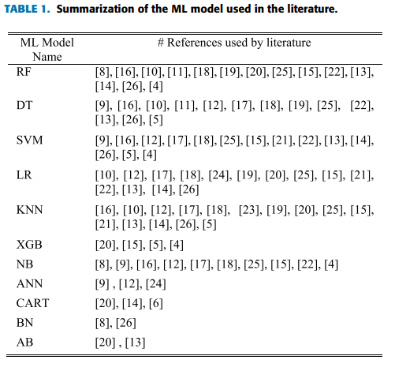
The above-related articles, particularly those on selected ML models for HD risk prediction, have noted the number of occurrences of each used model in the entire literature for the model selection. Table 1 helps to select the appropriate ML model for further deployment. The RF, DT, LR, and SVM classifiers are selected for this study due to their frequent usage and corresponding moderate-to-high-performance results ranging from 83% to 95% accuracy, as observed by many researchers in the literature section. The KNN and NB declared results are not so good compared to others, implying they were not considered in this study. The high accuracy obtained by the articles in the literature on the XGB boosting-based model is deemed to produce better prediction results. So finally, five ML models were selected to get a more accurate model prediction result for HD detection. In summary, two key points are drawn based on the above review of the existing literature. First, no existing work has addressed overfitting or underfitting scenarios of ML models, and second hyper-parameter tuning is necessary to deploy prediction models based on the best-performing boosting ML classifier. These two factors have an impact on how well a classifier performs. The prime contribution of this research study is formulated and noted down as follows: • The most frequently used ML models are selected for initial deployment, with boosting-based metaensemble stacking proposed at the final stage for precise HD illness prediction. • The k-fold CV is used to eliminate the overfitting problem on low-data instances in this case. • Two hyperparameter tuning techniques, RandomizedSearchCV and GridSearchCV, are added contributions to the search for the best hyperparameter values of each model and are executed to get the best possible results. • A hyperparameter-tuned model-based two-stage stacking ensemble prediction approach is introduced in this research study.
1)Effective Heart Disease Prediction Using Hybrid Machine Learning Techniques
AUTHORS: Senthil kumar mohan, chandrasegar thirumalai and Gautam Srivastva
Heart disease is one of the most significant causes of mortality in the world today. Prediction of cardiovascular disease is a critical challenge in the area of clinical data analysis. Machine learning (ML) has been shown to be effective in assisting in making decisions and predictions from the large quantity of data produced by the healthcare industry. We have also seen ML techniques being used in recent developments in different areas of the Internet of Things (IoT). Various studies give only a glimpse into predicting heart disease with ML techniques. In this paper, we propose a novel method that aims at finding significant features by applying machine learning techniques resulting in improving the accuracy in the prediction of cardiovascular disease. The prediction model is introduced with different combinations of features and several known classification techniques. We produce an enhanced performance level with an accuracy level of 88.7% through the prediction model for heart disease with the hybrid random forest with a linear model (HRFLM).
2)Prediction of Heart Disease using Machine Learning Algorithms: A Survey
AUTHORS: Himanshu Sharma and M A Rizvi
Health care field has a vast amount of data, for processing those data certain techniques are used. Data mining is one of the techniques often used. Heart disease is the Leading cause of death worldwide. This System predicts the arising possibilities of Heart Disease. The outcomes of this system provide the chances of occurring heart disease in terms of percentage. The datasets used are classified in terms of medical parameters. This system evaluates those parameters using data mining classification technique. The datasets are processed in python programming using two main Machine Learning Algorithm namely Decision Tree Algorithm and Naive Bayes Algorithm which shows the best algorithm among these two in terms of accuracy level of heart disease.
3)Prediction of Heart Diseases Using Data Mining and Machine Learning Algorithms and Tools
AUTHORS: M. Nikhil Kumar, K. V. S. Koushik, K. Deepak
Objectives: The objective of our work is to analyse various data mining tools and techniques in health care domain that can be employed in prediction of heart disease system and their efficient diagnosis. Methods/Statistical Analysis: A heart disease prediction model, which implements data mining technique, can help the medical practitioners in detecting the heart disease status based on the patient's clinical data. Data mining classification techniques for good decision making in the field of health care addressed are namely Decision trees, Naive Bayes, Neural Networks and Support Vector Machines. Hybridizing or combining any of these algorithms helps to make decisions quicker and more precise. Findings: Data mining is a powerful new technology for the extraction of hidden predictive and actionable information from large databases that can be used to gain deep and novel insights. Using advanced data mining techniques to excavate valuable information, has been considered as an activist approach to improve the quality and accuracy of healthcare service while lowering the healthcare cost and diagnosis time. Using this technique presence of heart disease can be predicted accurately. Using more input attributes such as controllable and uncontrollable risk factors, more accurate results could be achieved. Applications/Improvements: This method can be further expanded. It can use many of input attributes. Other data mining techniques are also be used for predication such as Clustering, Time series, Association rules. The unstructured data available in healthcare industry database can also be mined using text mining.
4)Application of Machine Learning in Diseases Prediction
AUTHORS:Pahulpreet Singh Kohli and Shriya Arora

The application of machine learning in the field of medical diagnosis is increasing gradually. This can be contributed primarily to the improvement in the classification and recognition systems used in disease diagnosis which is able to provide data that aids medical experts in early detection of fatal diseases and therefore, increase the survival rate of patients significantly. In this paper, we apply different classification algorithms, each with its own advantage on three separate databases of disease (Heart, Breast cancer, Diabetes) available in UCI repository for disease prediction. The feature selection for each dataset was accomplished by backward modeling using the p-value test. The results of the study strengthen the idea of the application of machine learning in early detection of diseases.

5)An Extensive Review on Swarm Robotics
AUTHORS:S. Kumra, R. Saxena, and S. Mehta.,
Swarm robotics is a new approach to the coordination of multi-robot systems which consist of large numbers of relatively simple robots which takes its inspiration from social insects. The most remarkable characteristic of swarm robots are the ability to work cooperatively to achieve a common goal. In this paper, classification of existing researches, problems and algorithms aroused in the study of swarm robotics are presented. The existing studies are classified into major areas and relevant sub-categories in the major areas.

In conclusion, the study's dual-stage stacked ensemble approach represents a promising direction in the application of machine learning for heart disease risk prediction, offering a robust, accurate, and interpretable model that could significantly impact preventive cardiology.

CHAPTER-2
SYSTEM ANALYSIS
EXISTING SYSTEM
1. Traditional Prediction Models
- Mostly based on logistic regression, decision trees, or basic neural networks.
- Rely on a limited number of features from clinical datasets.
2. Manual Feature Selection
- Often use manual or basic statistical techniques for feature selection.
- May overlook complex relationships between variables.
3. Limited Accuracy
- Existing models may suffer from lower prediction accuracy (e.g., ~70–80%) due to model simplicity and lack of depth in learning complex patterns.
4. Single-Layer Models
- Commonly use a single-layer or shallow ML model which may not capture hierarchical patterns in the data.
5. High False Positives/Negatives
- Risk of incorrect classification due to poor handling of non-linear and interdependent features.
6. Less Generalizable
- Performance may degrade on different datasets due to poor generalization.

Very few systems use the available clinical data for prediction purposes and even if they do ,they are restricted by the large number of association rules that apply.Diagnosis of the condition soley depends upon the Doctor's intuition and patient's records.The decision support system and will prove to be an aid for the physicians with the diagnosis.The algorithm,Fuzzy c means uses clustering and makes use of clusters and data points to predict the relativity of an attribute .Each data point is associated with multiple clusters depending upon the membership degrees
DISADAVANTAGES:
❖ Detection is not possible at an earlier stage
❖ Parctical use of various collected data is time consuming
PROPOSED SYSTEM
1. Dual State Stacked Machine (DSSM) Model
- Combines two levels of machine learning models (e.g., ensemble of classifiers at two different stages).
- Allows more complex and hierarchical learning.
2. Automated Feature Engineering
- Uses machine learning techniques to automatically select and combine the most predictive features from clinical datasets.
3. Higher Accuracy
- Improves prediction accuracy and reliability by using stacked ensembles and optimizing hyperparameters.
4. Efficient Computation
- Designed to reduce computational overhead while maintaining high performance.
- May include parallel processing or optimized libraries for faster training and prediction.
5. Better Generalization
- Performs better across diverse datasets, increasing model robustness and reducing overfitting.
6. Risk Categorization
- Predicts not just binary outcomes (disease/no disease) but risk levels (low, medium, high), aiding in preventive care.
7. Visualization Support
- Provides visual insights into risk factors and model predictions for doctors and patients.
To deal with the problem there is essential need of prediction system for awareness about diseases. Machine learning is the branch of Artificial Intelligence(AI), it provides prestigious support in predicting any kind of event which take training from natural events.we calculate accuracy of machine learning algorithms for predicting heart disease, for this algorithms are k-nearest neighbor, decision tree, linear regression and support vector machine(SVM) by using UCI repository dataset for training and testing
ADAVANTAGES:
- High performance and accurancy rate
- Machine Learning Algorithms is very flexible and is widely in various domains with high rates of success

Summary: Comparison Table
Feature | Existing System | Proposed DSSM System
Model Type | Single-layer ML | Dual-state stacked ensemble
Accuracy | Moderate (70–80%) | High (>85%)
Feature Selection | Manual/basic | Automated and optimized
Generalization | Poor to moderate | Strong across datasets
Output | Binary prediction | Multi-level risk classification
Computation | Slower, less efficient | Optimized, faster computation
Clinical Use | Limited support | Enhanced support with visualizations

CHAPTER 3
METHODOLOGY
3.1 MACHINE LEARNING ALGORITHMS
Machine learning algorithms are computational models that enable machines, particularly computers, to learn from data and make predictions or decisions without being explicitly programmed. These algorithms utilize statistical techniques to recognize patterns, learn from experience, and improve their performance over time as they are exposed to more data.
3.2. DECISION TREE CLASSIFIERS

Decision tree classifiers are used successfully in many diverse areas. Their most important feature is the capability of capturing descriptive decision making knowledge from the supplied data. Decision tree can be generated from training sets. The procedure for such generation based on the set of objects (S), each belonging to one of the classes C1, C2, …, Ck is as follows:

Step 1. If all the objects in S belong to the same class, for example Ci, the decision tree for S consists of a leaf labeled with this class
Step 2. Otherwise, let T be some test with possible outcomes O1, O2,…, On. Each object in S has one outcome for T so the test partitions S into subsets S1, S2,… Sn where each object in Si has outcome Oi for T. T becomes the root of the decision tree and for each outcome Oi we build a subsidiary decision tree by invoking the same procedure recursively on the set Si.

GRADIENT BOOSTING
Gradient boosting is a machine learning technique used in regression and classification tasks, among others. It gives a prediction model in the form of an ensemble of weak prediction models, which are typically decision trees.^{[1][2]} When a decision tree is the weak learner, the resulting algorithm is called gradient-boosted trees; it usually outperforms random forest.A gradient-boosted trees model is built in a stage-wise fashion as in other boosting methods, but it generalizes the other methods by allowing optimization of an arbitrary differentiable loss function.

K-NEAREST NEIGHBORS (KNN)
- Simple, but a very powerful classification algorithm
- Classifies based on a similarity measure
- Non-parametric
- Lazy learning
- Does not “learn” until the test example is given
- Whenever we have a new data to classify, we find its K-nearest neighbors from the training data

Example

- Training dataset consists of k-closest examples in feature space
- Feature space means, space with categorization variables (non-metric variables)
- Learning based on instances, and thus also works lazily because instance close to the input vector for test or prediction may take time to occur in the training dataset

LOGISTIC REGRESSION CLASSIFIERS

Logistic regression analysis studies the association between a categorical dependent variable and a set of independent (explanatory) variables. The name logistic regression is used when the dependent variable has only two values, such as 0 and 1 or Yes and No. The name multinomial logistic regression is usually reserved for the case when the dependent variable has three or more unique values, such as Married, Single, Divorced, or Widowed. Although the type of data used for the dependent variable is different from that of multiple regression, the practical use of the procedure is similar.

Logistic regression competes with discriminant analysis as a method for analyzing categorical-response variables. Many statisticians feel that logistic regression is more versatile and better suited for modeling most situations than is discriminant analysis. This is because logistic regression does not assume that the independent variables are normally distributed, as discriminant analysis does.

This program computes binary logistic regression and multinomial logistic regression on both numeric and categorical independent variables. It reports on the regression equation as well as the goodness of fit, odds ratios, confidence limits, likelihood, and deviance. It performs a comprehensive residual analysis including diagnostic residual reports and plots. It can perform an independent variable subset selection search, looking for the best regression model with the fewest independent variables. It provides confidence intervals on predicted values and provides ROC curves to help determine the best cutoff point for classification. It allows you to validate your results by automatically classifying rows that are not used during the analysis.

NAÏVE BAYES

The naive bayes approach is a supervised learning method which is based on a simplistic hypothesis: it assumes that the presence (or absence) of a particular feature of a class is unrelated to the presence (or absence) of any other feature .
Yet, despite this, it appears robust and efficient. Its performance is comparable to other supervised learning techniques. Various reasons have been advanced in the literature. In this tutorial, we highlight an explanation based on the representation bias. The naive bayes classifier is a linear classifier, as well as linear discriminant analysis, logistic regression or linear SVM (support vector machine). The difference lies on the method of estimating the parameters of the classifier (the learning bias).

While the Naive Bayes classifier is widely used in the research world, it is not widespread among practitioners which want to obtain usable results. On the one hand, the researchers found especially it is very easy to program and implement it, its parameters are easy to estimate, learning is very fast even on very large databases, its accuracy is reasonably good in comparison to the other approaches. On the other hand, the final users do not obtain a model easy to interpret and deploy, they does not understand the interest of such a technique.

Thus, we introduce in a new presentation of the results of the learning process. The classifier is easier to understand, and its deployment is also made easier. In the first part of this tutorial, we present some theoretical aspects of the naive bayes classifier. Then, we implement the approach on a dataset with Tanagra. We compare the obtained results (the parameters of the model) to those obtained with other linear approaches such as the logistic regression, the linear discriminant analysis and the linear SVM. We note that the results are highly consistent. This largely explains the good performance of the method in comparison to others. In the second part, we use various tools on the same dataset (Weka 3.6.0, R 2.9.2, Knime 2.1.1, Orange 2.0b and RapidMiner 4.6.0). We try above all to understand the obtained results.

RANDOM FOREST
Random forests or random decision forests are an ensemble learning method for classification, regression and other tasks that operates by constructing a multitude of decision trees at training time. For classification tasks, the output of the random forest is the class selected by most trees. For regression tasks, the mean or average prediction of the individual trees is returned. Random decision forests correct for decision trees' habit of overfitting to their training set. Random forests generally outperform decision trees, but their accuracy is lower than gradient boosted trees. However, data characteristics can affect their performance.
The first algorithm for random decision forests was created in 1995 by Tin Kam Ho[1] using the random subspace method, which, in Ho's formulation, is a way to implement the "stochastic discrimination" approach to classification proposed by Eugene Kleinberg.
An extension of the algorithm was developed by Leo Breiman and Adele Cutler, who registered "Random Forests" as a trademark in 2006 (as of 2019, owned by Minitab, Inc.).The extension combines Breiman's "bagging" idea and random selection of features, introduced first by Ho[1] and later independently by Amit and Geman[13] in order to construct a collection of decision trees with controlled variance.
Random forests are frequently used as "blackbox" models in businesses, as they generate reasonable predictions across a wide range of data while requiring little configuration.
SVM

In classification tasks a discriminant machine learning technique aims at finding, based on an independent and identically distributed (iid) training dataset, a discriminant function that can correctly predict labels for newly acquired instances. Unlike generative machine learning approaches, which require computations of conditional probability distributions, a discriminant classification function takes a data point x and assigns it to one of the different classes that are a part of the classification task. Less powerful than generative approaches, which are mostly used when prediction involves outlier detection, discriminant approaches require fewer computational resources and less training data, especially for a multidimensional feature space and when only posterior probabilities are needed. From a geometric perspective, learning a classifier is equivalent to finding the equation for a multidimensional surface that best separates the different classes in the feature space.

SVM is a discriminant technique, and, because it solves the convex optimization problem analytically, it always returns the same optimal hyperplane parameter—in contrast to genetic algorithms (GAs) or perceptrons, both of which are widely used for classification in machine learning. For perceptrons, solutions are highly dependent on the initialization and termination criteria. For a specific kernel that transforms the data from the input space to the feature space, training returns uniquely defined SVM model parameters for a given training set, whereas the perceptron and GA classifier models are different each time training is initialized. The aim of GAs and perceptrons is only to minimize error during training, which will translate into several hyperplanes’ meeting this requirement.

3.3 MATPLOTLIB
Matplotlib is a Python 2D plotting library which produces publication quality figures in a variety of hardcopy formats and interactive environments across platforms. Matplotlib can be used in Python scripts, the Python and IPython shells, the Jupyter notebook, web application servers, and four graphical user interface toolkits. It provides a variety of functions to visualize data and create static, animated, and interactive plots. Matplotlib is widely used for tasks ranging from simple line plots to complex visualizations.

The Visualization Design using matplotlib
- Bar Graph
- Pie Chart
- Box Plot
- Histogram
- Line Chart and Subplots
- Scatter Plot

3.4 BAR GRAPH
Bar graphs are best used when we need to compare the quantity of categorical values within the same category. Bar graphs should not be used for continuous values.
Bar graph is generated using plt.bar() in matplotlib
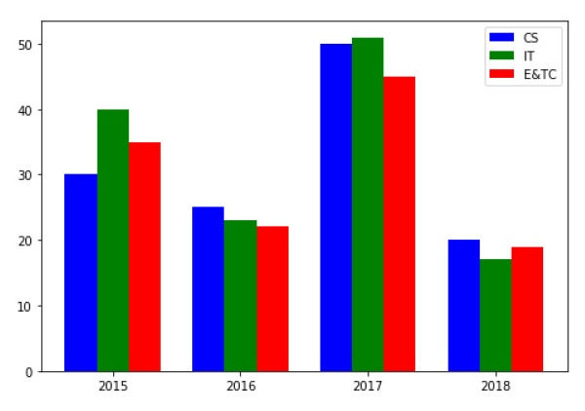
Figure 3.3. Bar Graph

3.5 PIE CHART USING MATPLOTLIB
A pie chart is suitable to show the proportional distribution of items within the same category.plt.pie() is used to draw the pie chart and adjust its parameters to make it more appealing.
A pie chart is rendered useless when there are a lot of items within a category. This will decrease the size of each slice and there will be no distinction between the items.
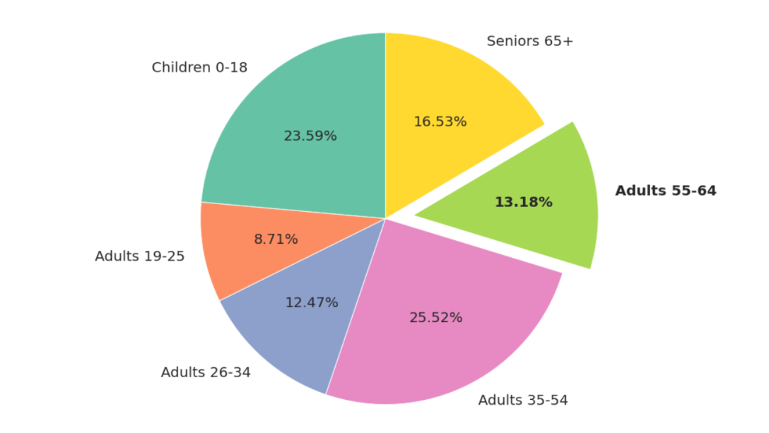
Figure 3.4. Pie Chart

3.6 BOX PLOT USING MATPLOTLIB
Box plot gives statistical information about the distribution of numeric data divided into different groups. It is useful for detecting outliers within each group. The lower, middle and upper part of the box represents the 25th, 50th, and 75th percentile values respectively. Box plot does not show the distribution of data points within each group.
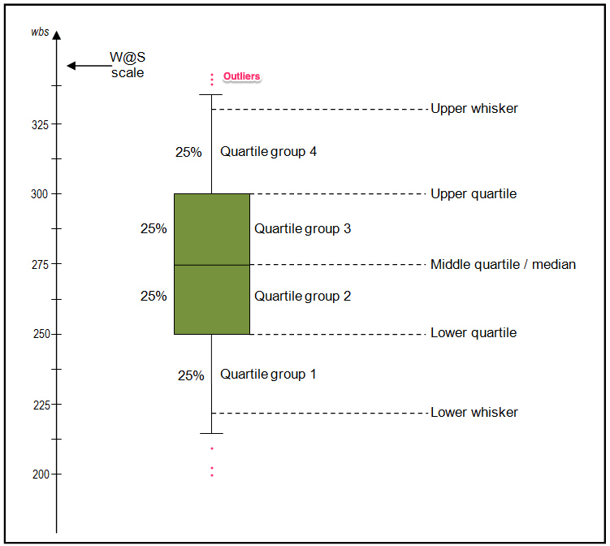
Figure 3.5. Box Plot

3.7 HISTOGRAM USING MATPLOTLIB
A histogram shows the distribution of numeric data through a continuous interval by segmenting data into different bins. Useful for inspecting skewness in the data. It is easy to confuse histograms with bar plots. But remember, histograms are used with continuous data whereas bar plots are used with categorical data.
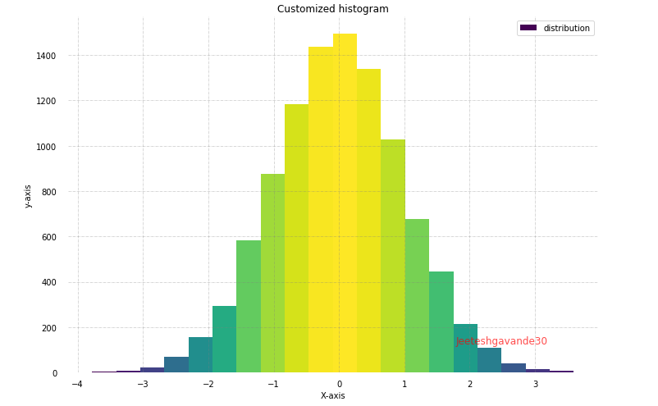
Figure 3.6. Histogram

3.8 LINE PLOT AND SUBPLOTS USING MATPLOTLIB
A line plot is useful for visualizing the trend in a numerical value over a continuous time interval. Matplotlib subplots makes it easy to view and compare different plots in the same figure. The plt.subplots() figure returns the figure and axes. You can provide as an input to the function how you want to display the axes within the figure. These will be adjusted using the nrows and ncols parameters. You can even adjust the size of the figure using the figsize parameter.
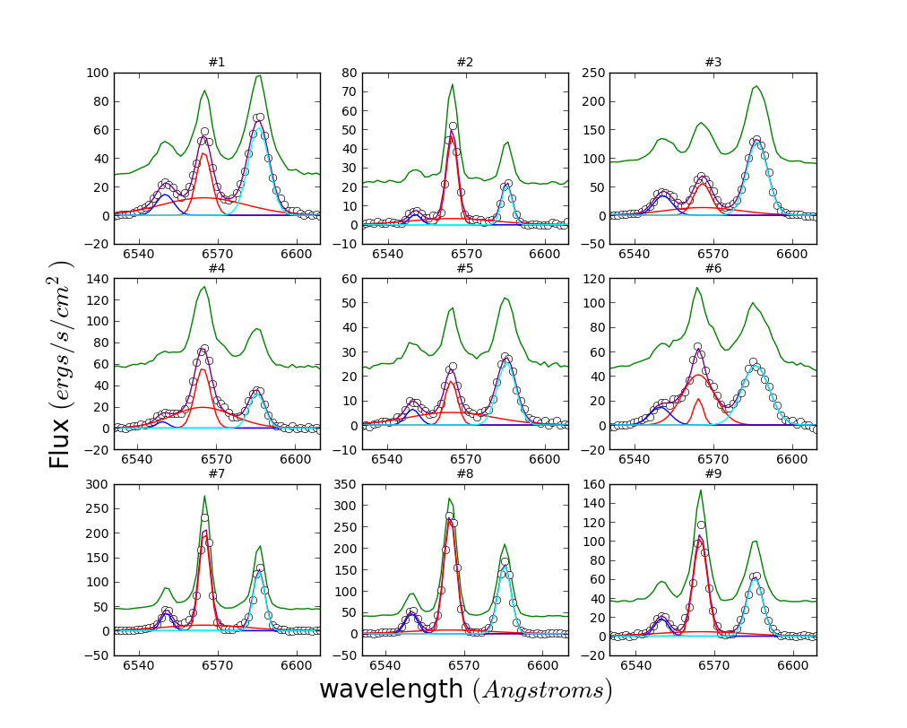
Figure 3.7. Subplot

3.9 SCATTER PLOT USING MATPLOTLIB
Scatter plots are useful for showing the relationship between two variables. Any correlation between variables or outliers in the data can be easily spotted using scatter plots.
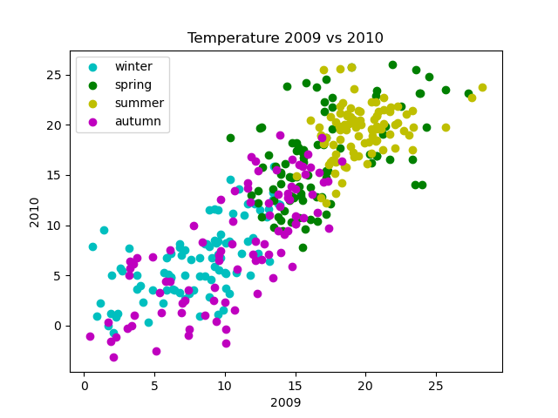
Figure 3.8. Scatter Plot
3.10 SEABORN
Seaborn is a statistical data visualization library based on Matplotlib. Seaborn is a powerful and flexible data visualization library in Python that offers an easy-to-use interface for creating informative and aesthetically pleasing statistical graphics. It provides a range of tools for visualizing data, including advanced statistical analysis, and makes it easy to create complex multi-plot visualizations..Seaborn's key benefit lies in its capability to generate attractive plots with minimal coding efforts. It provides a range of default themes and color palettes, which you can easily customize to suit your preferences. Additionally, Seaborn offers a range of built-in statistical functions, allowing users to easily perform complex statistical analysis with their visualizations. Another notable feature of Seaborn is its ability to create complex multi-plot visualizations. With Seaborn, users can create grids of plots that allow for easy comparison between multiple variables or subsets of data. This makes it an ideal tool for exploratory data analysis and presentation.
3.11 PLOT TYPES IN SEABORN
- LINE PLOT: Line plots are used to visualize trends in data over time or other continuous variables. In a line plot, each data point is connected by a line, creating a smooth curve. In Seaborn, line plots can be created using the lineplot() function.
- HISTOGRAM: Histograms visualize the distribution of a continuous variable. In a histogram, the data is divided into bins and the height of each bin represents the frequency or count of data points within that bin. In Seaborn, histograms can be created using the histplot() function.
- BOX PLOT: Box plots are a type of visualization that shows the distribution of a dataset. They are commonly used to compare the distribution of one or more variables across different categories.
- VIOLIN PLOT: A violin plot is a type of data visualization that combines aspects of both box plots and density plots. It displays a density estimate of the data, usually smoothed by a kernel density estimator, along with the interquartile range (IQR) and median in a box plot-like form. The width of the violin represents the density estimate, with wider parts indicating higher density, and the IQR and median are shown as a white dot and line within the violin.
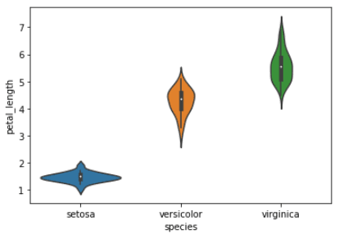
Figure 3.9. Violin Plot
- HEATMAP. A heatmap is a graphical representation of data that uses colors to depict the value of a variable in a two-dimensional space. Heatmaps are commonly used to visualize the correlation between different variables in a dataset.
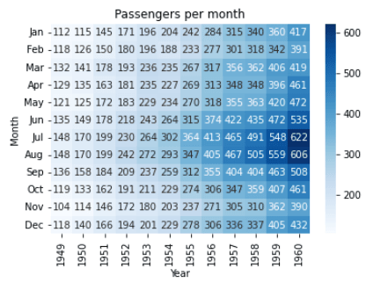
Figure 3.10. Heat Map
- PAIRPLOT: Pair plots are a type of visualization in which multiple pairwise scatter plots are displayed in a matrix format. Each scatter plot shows the relationship between two variables, while the diagonal plots show the distribution of the individual variables.
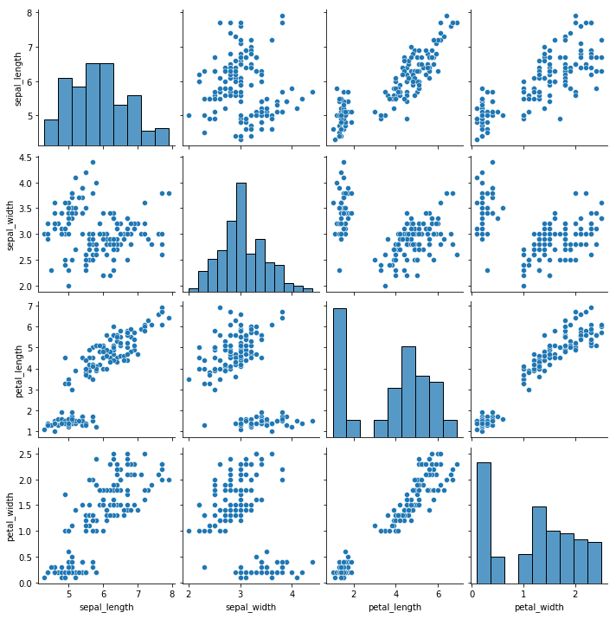
Figure 3.11. Pair Plot

CHAPTER 4:
TOOLS/ HARDWARE & SOFTWARE REQUIREMENTS
HTML and JavaScript: The HTML structure defines the login page content, layout, and interactive elements. JavaScript provides dynamic functionality, including interactions and input validation reCAPTCHA:
This page references Google reCAPTCHA (https://www.gstatic.com/recaptcha) to prevent automated bots from accessing the login system, providing an added layer of security. Wordtune: A script for Wordtune is installed on the page, which might assist in text-related enhancements. Tailwind CSS: Tailwind CSS framework is applied for utility-based styling, allowing modular design and rapid customization.
Font Awesome Icons: Several icon classes (svg-inline--fa) suggest the use of Font Awesome for icons, aiding in visual cues for users on the login page.

HARDWARE-REQUIRMENTS:
- System : i3 or above.
- Ram : 4 GB.
- Hard Disk : 40 GB
SOFTWARE REQUIRMENTS :
- Operating system : Windows8 or Above.
- Coding Language : python

CHAPTER-5
IMPLEMENTATION & SYSTEM DESIGN
MODULES
Service Provider
In this module, the Service Provider has to login by using valid user name and password. After login successful he can do some operations such as Login, Train & Test Stroke Datasets, View Stroke Datasets Trained and Tested Accuracy in Bar Chart, View Stroke Datasets Trained and Tested Accuracy Results, View Stroke Risk Prediction Type, View Stroke Risk Prediction Type Ratio, Download Predicted Data Sets, View Stroke Risk Prediction Type Ratio Results, View All Remote Users.
View and Authorize Users
In this module, the admin can view the list of users who all registered. In this, the admin can view the user’s details such as, user name, email, address and admin authorizes the users.
Remote User
In this module, there are n numbers of users are present. User should register before doing any operations. Once user registers, their details will be stored to the database. After registration successful, he has to login by using authorized user name and password. Once Login is successful user will do some operations like REGISTER AND LOGIN, PREDICT STROKE RISK PREDICTION TYPE, VIEW YOUR PROFILE.
5.2. SYSTEM DESIGN
SYSTEM ARCHITECTURE
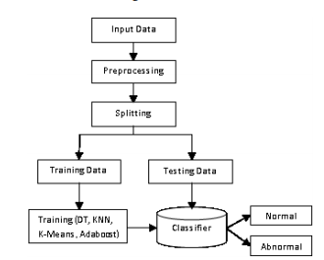
UML DIAGRAMS
UML stands for Unified Modeling Language. UML is a standardized general-purpose modeling language in the field of object-oriented software engineering. The standard is managed, and was created by, the Object Management Group.
The goal is for UML to become a common language for creating models of object oriented computer software. In its current form UML is comprised of two major components: a Meta-model and a notation. In the future, some form of method or process may also be added to; or associated with, UML.
The Unified Modeling Language is a standard language for specifying, Visualization, Constructing and documenting the artifacts of software system, as well as for business modeling and other non-software systems.
The UML represents a collection of best engineering practices that have proven successful in the modeling of large and complex systems.
The UML is a very important part of developing objects oriented software and the software development process. The UML uses mostly graphical notations to express the design of software projects.

GOALS:
The Primary goals in the design of the UML are as follows:
1. Provide users a ready-to-use, expressive visual modeling Language so that they can develop and exchange meaningful models.
2. Provide extendibility and specialization mechanisms to extend the core concepts.
3. Be independent of particular programming languages and development process.
4. Provide a formal basis for understanding the modeling language.
5. Encourage the growth of OO tools market.
6. Support higher level development concepts such as collaborations, frameworks, patterns and components.
7. Integrate best practices.

USE CASE DIAGRAM:
A use case diagram in the Unified Modeling Language (UML) is a type of behavioral diagram defined by and created from a Use-case analysis. Its purpose is to present a graphical overview of the functionality provided by a system in terms of actors, their goals (represented as use cases), and any dependencies between those use cases. The main purpose of a use case diagram is to show what system functions are performed for which actor. Roles of the actors in the system can be depicted.

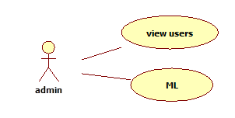
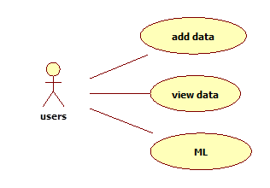

CLASS DIAGRAM:
In software engineering, a class diagram in the Unified Modeling Language (UML) is a type of static structure diagram that describes the structure of a system by showing the system's classes, their attributes, operations (or methods), and the relationships among the classes. It explains which class contains information

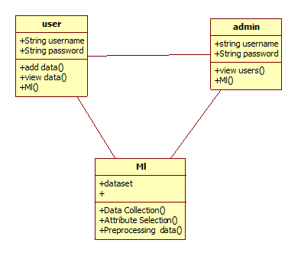
SEQUENCE DIAGRAM:
A sequence diagram in Unified Modeling Language (UML) is a kind of interaction diagram that shows how processes operate with one another and in what order. It is a construct of a Message Sequence Chart. Sequence diagrams are sometimes called event diagrams, event scenarios, and timing diagrams.
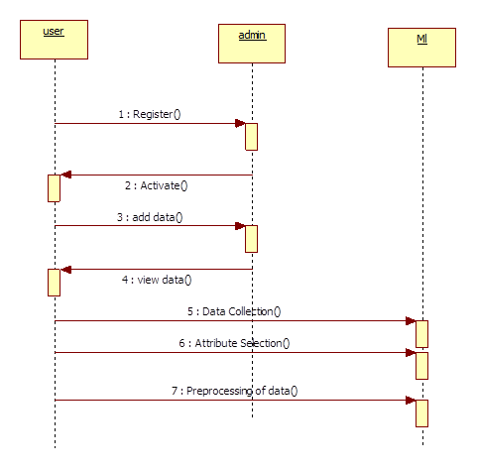

ACTIVITY DIAGRAM:
Activity diagrams are graphical representations of workflows of stepwise activities and actions with support for choice, iteration and concurrency. In the Unified Modeling Language, activity diagrams can be used to describe the business and operational step-by-step workflows of components in a system. An activity diagram shows the overall flow of control
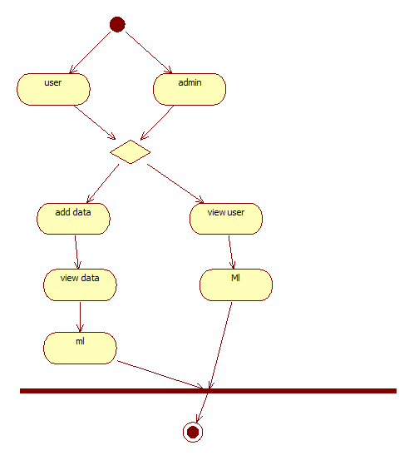
COLLABORATION DIAGRAM
A collaboration diagram, also known as a communication diagram, is an illustration of the relationships and interactions among software objects in the Unified Modeling Language (UML). Developers can use these diagrams to portray the dynamic behavior of a particular use case and define the role of each object
A Collaboration Diagram (also called a Communication Diagram) shows how objects interact to perform a behavior, emphasizing the relationships and interactions between them.
For “An Efficient Computation Risk Prediction Model of Heart Diseases Based on Dual State Stacked Machine”, the collaboration diagram outlines the interactions between components like data sources, preprocessing units, machine learning models, and output systems.
Concept Summary of the System
Before diving into the diagram:
- Dual State Stacked Machine refers to a two-layered or hybrid ensemble model.
- The system receives patient data → processes it → feeds it into multiple models → stacks the predictions → outputs a final risk score.
Key Objects in the Collaboration Diagram
Here are the typical objects and their collaboration roles:
- User Interface (UI) – For data input and result output.
- Patient Data – Input object containing medical records (e.g., age, blood pressure, cholesterol).
- Data Preprocessing Module – Cleans and prepares the data.
- Feature Extractor – Derives meaningful features for modeling.
- Model Layer 1 (Base Learners) – First stack of ML models (e.g., SVM, Random Forest).
- Model Layer 2 (Meta Learner) – Combines outputs of base learners (e.g., Logistic Regression).
- Risk Predictor – Final component that delivers the heart disease risk level.
- Result Output – Displays prediction and recommendations.
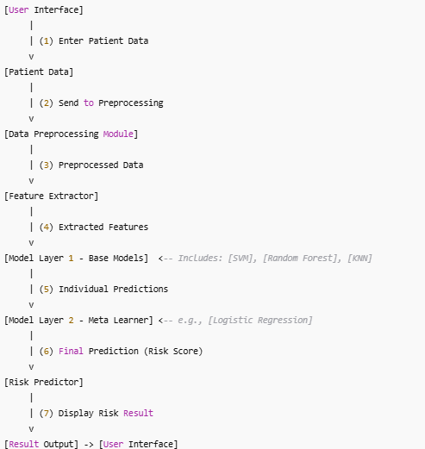
COMPONENT DIAGRAM
Component diagrams are used in modeling the physical aspects of object-oriented systems that are used for visualizing, specifying, and documenting component-based systems and also for constructing executable systems through forward and reverse engineering. Component diagrams are essentially class diagrams that focus on a system's components that often used to model the static implementation view of a system
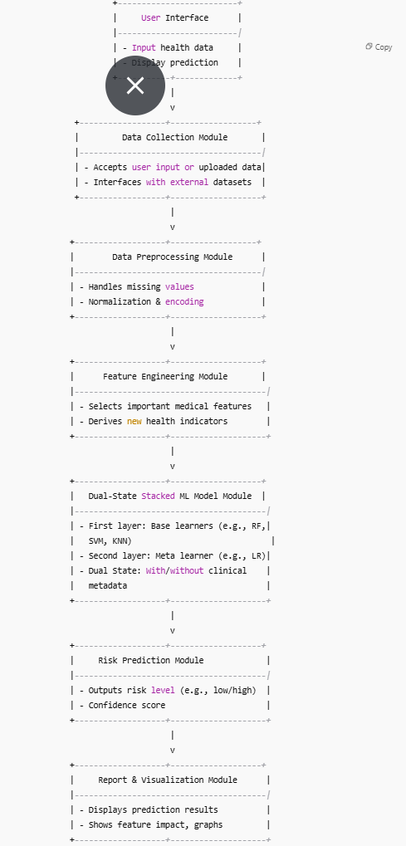
DATA FLOW DIAGRAM:
1. The DFD is also called as bubble chart. It is a simple graphical formalism that can be used to represent a system in terms of input data to the system, various processing carried out on this data, and the output data is generated by this system.
2. The data flow diagram (DFD) is one of the most important modeling tools. It is used to model the system components. These components are the system process, the data used by the process, an external entity that interacts with the system and the information flows in the system.
3. DFD shows how the information moves through the system and how it is modified by a series of transformations. It is a graphical technique that depicts information flow and the transformations that are applied as data moves from input to output.
4. DFD is also known as bubble chart. A DFD may be used to represent a system at any level of abstraction. DFD may be partitioned into levels that represent increasing information flow and functional detail
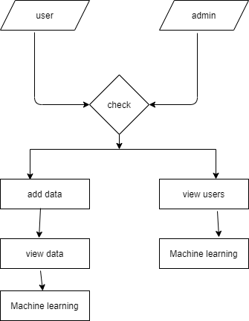

0-Level Data Flow Diagram (DFD)
Level 0 is the highest-level Data Flow Diagram (DFD), which provides an overview of the entire system. It shows the major processes, data flows, and data stores in the system, without providing any details about the internal workings of these processes.
It is also known as a context diagram. It’s designed to be an abstraction view, showing the system as a single process with its relationship to external entities. It represents the entire system as a single bubble with input and output data indicated by incoming/outgoing arrows
Components of the 0-Level DFD
External Entities:
- User (Patient or Doctor) – Provides input data and receives prediction results.
- Medical Database – Source of historical patient records and heart disease datasets.
Process:
- Heart Disease Risk Prediction System
(Based on Dual State Stacked Machine Learning Model)
Data Stores (optional at 0-level but can be shown abstractly):
- Can be represented as part of the system: Patient Records, Model Training Data, etc.
Data Flows:
- User Data: Personal details, symptoms, diagnostic inputs.
- Historical Data: Labeled data used for model training.
- Prediction Request: Trigger for risk assessment.
- Risk Report: Prediction results and risk level.
- Training Feedback: Data used to improve model performance.

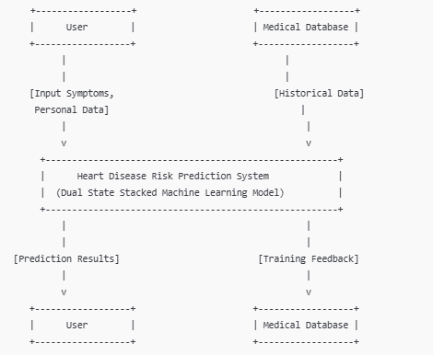
Summary of Data Flows
External Entity | Direction | Data Flow
User | → | Input data (symptoms, health records)
User | ← | Risk prediction result
Medical Database | → | Historical heart disease data
Medical Database | ← | Model feedback/training updates
1-Level Data Flow Diagram (DFD)
1-Level provides a more detailed view of the system by breaking down the major processes identified in the level 0 Data Flow Diagram (DFD) into sub-processes. Each sub-process is depicted as a separate process on the level 1 Data Flow Diagram (DFD). The data flows and data stores associated with each sub-process are also shown.
In 1-level Data Flow Diagram (DFD), the context diagram is decomposed into multiple bubbles/processes. In this level, we highlight the main functions of the system and breakdown the high-level process of 0-level Data Flow Diagram (DFD) into subprocesses
Level 1 DFD Components
External Entities:
- Patient
- Medical Staff (Doctor/Nurse)
Processes:
- 1.0 Collect Patient Data
- 2.0 Preprocess & Feature Engineering
- 3.0 Predict Heart Disease Risk
- 4.0 Generate Report & Recommendation
Data Stores:
- D1: Patient Database
- D2: Model Database (Trained Model Parameters)
- D3: Risk Reports Archive
Data Flows:
- Input data from patients (e.g., age, cholesterol, BP, ECG results)
- Preprocessed data to ML model
- Prediction results and feedback
- Stored reports for future reference
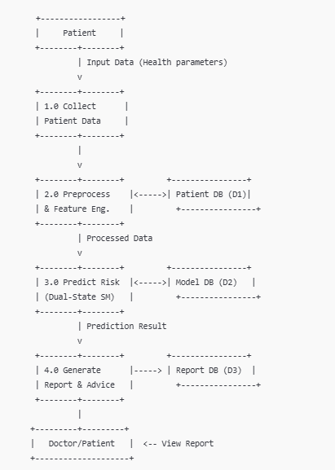
2-Level Data Flow Diagram (DFD)
2-Level provides an even more detailed view of the system by breaking down the sub-processes identified in the level 1 Data Flow Diagram (DFD) into further sub-processes. Each sub-process is depicted as a separate process on the level 2 DFD. The data flows and data stores associated with each sub-process are also shown.
2-Level Data Flow Diagram (DFD) goes one step deeper into parts of 1-level DFD. It can be used to plan or record the specific/necessary detail about the system’s functioning
Context Overview (Level 0 DFD)
This is a high-level view of the system that shows external entities and the system as a single process.
Entities:
- User / Medical Practitioner – Provides patient data and receives predictions.
- Health Database – Supplies patient history or records.
Process:
- 0: Heart Disease Risk Prediction System
Data Flows:
- User → Patient Data → System
- System → Risk Prediction Result → User
- Health Database → Historical Data → System
Level 1 DFD
Breaks down the main system into its core subprocesses.
Processes:
- 1.1 Data Input and Collection
  - Receives patient input data (e.g., age, cholesterol, BP, ECG, etc.)
- 1.2 Data Preprocessing
  - Cleans missing values, normalizes features, encodes categorical data.
- 1.3 Feature Extraction & Selection
  - Selects most relevant medical features using statistical or ML methods.
- 1.4 Dual State Stacked Machine Model
  - Executes the stacked ML model (e.g., ensemble of classifiers) to compute risk.
- 1.5 Prediction & Result Interpretation
  - Produces and interprets the heart disease risk level (e.g., Low, Medium, High).
- 1.6 Result Reporting & Feedback
  - Delivers results and recommendations to the user.

Data Stores:
- D1: Patient Database – Stores user input and medical records.
- D2: Model Knowledge Base – Stores trained model and feature weights.
- D3: Results Archive – Stores historical predictions and feedback.

Data Flows (Connections):
- User → 1.1: Provides input parameters.
- 1.1 → 1.2: Raw patient data.
- 1.2 → 1.3: Cleaned and structured data.
- 1.3 → 1.4: Key features.
- D1 ↔ 1.1 / 1.2: Retrieve/store patient history.
- D2 → 1.4: Model weights/config.
- 1.4 → 1.5: Risk score or classification.
- 1.5 → 1.6: Interpreted result.
- 1.6 → User: Final prediction and advice.
- 1.5 → D3: Store result and logs.

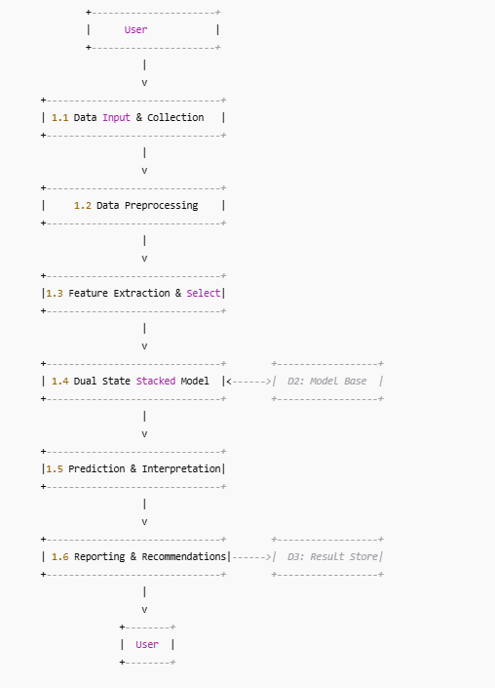
3-Level Data Flow Diagram (DFD)
3-Level is the most detailed level of Data Flow Diagram (DFDs), which provides a detailed view of the processes, data flows, and data stores in the system. This level is typically used for complex systems, where a high level of detail is required to understand the system. Each process on the level 3 DFD is depicted with a detailed description of its input, processing, and output. The data flows and data stores associated with each process are also shown.
Advantages of using Data Flow Diagrams (DFD)
Following are the Advantage of Data Flow Diagram (DFD) :
- Easy to understand: DFDs are graphical representations that are easy to understand and communicate, making them useful for non-technical stakeholders and team members.
- Improves system analysis: DFDs are useful for analyzing a system's processes and data flow, which can help identify inefficiencies, redundancies, and other problems that may exist in the system.
- Supports system design: DFDs can be used to design a system's architecture and structure, which can help ensure that the system is designed to meet the requirements of the stakeholders.
- Enables testing and verification: DFDs can be used to identify the inputs and outputs of a system, which can help in the testing and verification of the system's functionality.
- Facilitates documentation: DFDs provide a visual representation of a system, making it easier to document and maintain the system over time.
Disadvantages of using Data Flow Diagram (DFD)
Following are the Disadvantage of Data Flow Diagram (DFD) :
- Can be time-consuming: Creating DFDs can be a time-consuming process, especially for complex systems.
- Limited focus: DFDs focus primarily on the flow of data in a system, and may not capture other important aspects of the system, such as user interface design, system security, or system performance.
- Can be difficult to keep up-to-date: DFDs may become out-of-date over time as the system evolves and changes.
- Requires technical expertise: While DFDs are easy to understand, creating them requires a certain level of technical expertise and familiarity with the system being analyzed

CHAPTER-6
SOFTWARE REQUIREMENTS AND TESTING
Functional Requirements
These define what the system should do:
- User Data Input
  - The system must accept clinical input data (e.g., age, gender, blood pressure, cholesterol levels, heart rate, ECG results, lifestyle factors, etc.).
  - Optionally accept medical history or lab results via manual input or upload.
- Data Preprocessing
  - The system should clean, normalize, and encode input data.
  - Handle missing values and detect outliers.
- Feature Selection/Engineering
  - Select or derive relevant features based on medical relevance and model performance metrics.
- Model Integration (Dual-State Stacked Machine)
  - Implement a dual-state model that stacks two or more machine learning algorithms for improved accuracy and robustness.
  - Each state (layer) should process intermediate outputs from the previous one.
- Risk Prediction
  - The system should output a risk level prediction for heart disease (e.g., low, medium, high).
  - Optionally provide a risk score or probability (e.g., 82% chance of heart disease).
- Result Interpretation
  - Display results with explanations (e.g., feature importance or contribution to risk score).
  - Provide visualizations such as bar charts or radar graphs.
- Model Evaluation
  - Provide performance metrics such as accuracy, precision, recall, F1-score, AUC.
- User Management (if web or app-based)
  - Allow secure user authentication and profile management.
  - Store past predictions for longitudinal tracking.
- Report Generation
  - Generate downloadable or printable reports for patients or doctors.
- Model Retraining and Updating
- Enable periodic model retraining with new or additional datasets to improve accuracy.

🔒 Non-Functional Requirements
These define how well the system performs its tasks:
- Performance and Efficiency
  - The system should generate predictions within 2–5 seconds.
  - The dual-state stacked model should be optimized for computation time and memory usage.
- Accuracy and Reliability
  - The model should achieve at least 85–90% accuracy based on validation datasets.
  - Ensure reproducible results for the same input data.
- Scalability
  - Support batch processing or multiple concurrent users.
  - Should be deployable in both standalone and cloud environments.
- Security and Privacy
  - Use encryption (e.g., SSL/TLS, AES) for data transmission and storage.
  - Comply with medical data regulations (e.g., HIPAA, GDPR).
  - Protect patient records and sensitive medical data.
- Usability
  - The system UI should be intuitive, even for non-technical users (e.g., clinicians).
  - Use clear icons, labels, and feedback messages.
- Maintainability
  - Code should be modular, documented, and easy to update or debug.
  - Support easy integration of new models or data sources.
- Availability and Reliability
  - System uptime should be 99% or higher.
  - Provide fallback mechanisms in case of prediction failure.
- Portability
  - The model should be deployable on different operating systems or platforms (Windows, Linux, Web, Mobile).
- Auditability
  - Keep logs of predictions and data inputs for traceability and audits
SOFTWARE ENVIRONMENT
Python:
Python is a high-level, interpreted, interactive and object-oriented scripting language. Python is designed to be highly readable. It uses English keywords frequently where as other languages use punctuation, and it has fewer syntactical constructions than other languages.
- Python is Interpreted − Python is processed at runtime by the interpreter. You do not need to compile your program before executing it. This is similar to PERL and PHP.
- Python is Interactive − User can actually sit at a Python prompt and interact with the interpreter directly to write your programs.
- Python is Object-Oriented − Python supports Object-Oriented style or technique of programming that encapsulates code within objects.
- Python is a Beginner's Language − Python is a great language for the beginner-level programmers and supports the development of a wide range of applications from simple text processing to WWW browsers to games.
History of Python
Python was developed by Guido van Rossum in the late eighties and early nineties at the National Research Institute for Mathematics and Computer Science in the Netherlands.
Python is derived from many other languages, including ABC, Modula-3, C, C++, Algol-68, SmallTalk, and Unix shell and other scripting languages.
Python is copyrighted. Like Perl, Python source code is now available under the GNU General Public License (GPL).
Python is now maintained by a core development team at the institute, although Guido van Rossum still holds a vital role in directing its progress.
Python Features
Python's features include −
- Easy-to-learn − Python has few keywords, simple structure, and a clearly defined syntax. This allows the student to pick up the language quickly.
- Easy-to-read − Python code is more clearly defined and visible to the eyes.
- Easy-to-maintain − Python's source code is fairly easy-to-maintain.
- A broad standard library − Python's bulk of the library is very portable and cross-platform compatible on UNIX, Windows, and Macintosh.
- Interactive Mode − Python has support for an interactive mode which allows interactive testing and debugging of snippets of code.
- Portable − Python can run on a wide variety of hardware platforms and has the same interface on all platforms.
- Extendable − You can add low-level modules to the Python interpreter. These modules enable programmers to add to or customize their tools to be more efficient.
- Databases − Python provides interfaces to all major commercial databases.
- GUI Programming − Python supports GUI applications that can be created and ported to many system calls, libraries and windows systems, such as Windows MFC, Macintosh, and the X Window system of Unix.
- Scalable − Python provides a better structure and support for large programs than shell scripting.
Apart from the above-mentioned features, Python has a big list of good features, few are listed below −
- It supports functional and structured programming methods as well as OOP.
- It can be used as a scripting language or can be compiled to byte-code for building large applications.
- It provides very high-level dynamic data types and supports dynamic type checking.
- It supports automatic garbage collection.
- It can be easily integrated with C, C++, COM, ActiveX, CORBA, and Java.
Python is available on a wide variety of platforms including Linux and Mac OS X. Let's understand how to set up our Python environment.
Getting Python
The most up-to-date and current source code, binaries, documentation, news, etc., is available on the official website of Python https://www.python.org.
Windows Installation
Here are the steps to install Python on Windows machine.
- Open a Web browser and go to https://www.python.org/downloads/.
- Follow the link for the Windows installer python-XYZ.msifile where XYZ is the version you need to install.
- To use this installer python-XYZ.msi, the Windows system must support Microsoft Installer 2.0. Save the installer file to your local machine and then run it to find out if your machine supports MSI.
- Run the downloaded file. This brings up the Python install wizard, which is really easy to use. Just accept the default settings, wait until the install is finished, and you are done.
The Python language has many similarities to Perl, C, and Java. However, there are some definite differences between the languages.

First Python Program
Let us execute programs in different modes of programming.

Interactive Mode Programming
Invoking the interpreter without passing a script file as a parameter brings up the following prompt −
$ python
Python2.4.3(#1,Nov112010,13:34:43)
[GCC 4.1.220080704(RedHat4.1.2-48)] on linux2
Type"help","copyright","credits"or"license"for more information.
>>>
Type the following text at the Python prompt and press the Enter −
>>>print"Hello, Python!"
If you are running new version of Python, then you would need to use print statement with parenthesis as in print ("Hello, Python!");. However in Python version 2.4.3, this produces the following result −
Hello, Python!

Script Mode Programming
Invoking the interpreter with a script parameter begins execution of the script and continues until the script is finished. When the script is finished, the interpreter is no longer active.
Let us write a simple Python program in a script. Python files have extension .py. Type the following source code in a test.py file −
print"Hello, Python!"
We assume that you have Python interpreter set in PATH variable. Now, try to run this program as follows −
$ python test.py
This produces the following result −
Hello, Python!

Flask Framework:
Flask is a web application framework written in Python. Armin Ronacher, who leads an international group of Python enthusiasts named Pocco, develops it. Flask is based on Werkzeug WSGI toolkit and Jinja2 template engine. Both are Pocco projects.
Http protocol is the foundation of data communication in world wide web. Different methods of data retrieval from specified URL are defined in this protocol.
The following table summarizes different http methods −
Sr.No | Methods & Description
1 | GET  Sends data in unencrypted form to the server. Most common method.
2 | HEAD  Same as GET, but without response body
3 | POST  Used to send HTML form data to server. Data received by POST method is not cached by server.
4 | PUT  Replaces all current representations of the target resource with the uploaded content.
5 | DELETE  Removes all current representations of the target resource given by a URL
By default, the Flask route responds to the GET requests. However, this preference can be altered by providing methods argument to route() decorator.
In order to demonstrate the use of POST method in URL routing, first let us create an HTML form and use the POST method to send form data to a URL.
Save the following script as login.html
<html>
<body>
<formaction="http://localhost:5000/login"method="post">
<p>Enter Name:</p>
<p><inputtype="text"name="nm"/></p>
<p><inputtype="submit"value="submit"/></p>
</form>
</body>
</html>
Now enter the following script in Python shell.
from flask importFlask, redirect,url_for, request
app=Flask(__name__)
@app.route('/success/<name>')
def success(name):
return'welcome %s'% name
@app.route('/login',methods=['POST','GET'])
def login():
ifrequest.method=='POST':
user=request.form['nm']
return redirect(url_for('success',name= user))
else:
user=request.args.get('nm')
return redirect(url_for('success',name= user))
if __name__ =='__main__':
app.run(debug =True)
After the development server starts running, open login.html in the browser, enter name in the text field and click Submit.
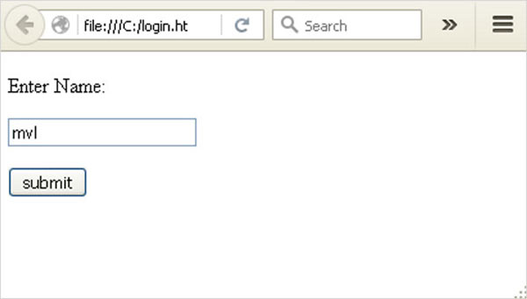
Form data is POSTed to the URL in action clause of form tag.
http://localhost/login is mapped to the login() function. Since the server has received data by POST method, value of ‘nm’ parameter obtained from the form data is obtained by −
user = request.form['nm']
It is passed to ‘/success’ URL as variable part. The browser displays a welcome message in the window.
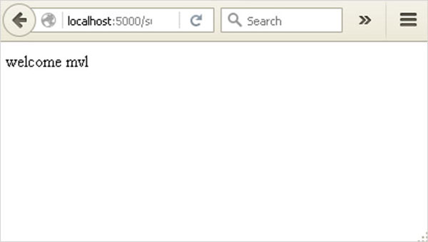
Change the method parameter to ‘GET’ in login.html and open it again in the browser. The data received on server is by the GET method. The value of ‘nm’ parameter is now obtained by −
User = request.args.get(‘nm’)
Here, args is dictionary object containing a list of pairs of form parameter and its corresponding value. The value corresponding to ‘nm’ parameter is passed on to ‘/success’ URL as before.

What is Python?
Python is a popular programming language. It was created in 1991 by Guido van Rossum.
It is used for:
- web development (server-side),
- software development,
- mathematics,
- system scripting.
What can Python do?
- Python can be used on a server to create web applications.
- Python can be used alongside software to create workflows.
- Python can connect to database systems. It can also read and modify files.
- Python can be used to handle big data and perform complex mathematics.
- Python can be used for rapid prototyping, or for production-ready software development.
Why Python?
- Python works on different platforms (Windows, Mac, Linux, Raspberry Pi, etc).
- Python has a simple syntax similar to the English language.
- Python has syntax that allows developers to write programs with fewer lines than some other programming languages.
- Python runs on an interpreter system, meaning that code can be executed as soon as it is written. This means that prototyping can be very quick.
- Python can be treated in a procedural way, an object-orientated way or a functional way.
Good to know
- The most recent major version of Python is Python 3, which we shall be using in this tutorial. However, Python 2, although not being updated with anything other than security updates, is still quite popular.
- In this tutorial Python will be written in a text editor. It is possible to write Python in an Integrated Development Environment, such as Thonny, Pycharm, Netbeans or Eclipse which are particularly useful when managing larger collections of Python files.
Python Syntax compared to other programming languages
- Python was designed to for readability, and has some similarities to the English language with influence from mathematics.
- Python uses new lines to complete a command, as opposed to other programming languages which often use semicolons or parentheses.
- Python relies on indentation, using whitespace, to define scope; such as the scope of loops, functions and classes. Other programming languages often use curly-brackets for this purpose.

Python Install
Many PCs and Macs will have python already installed.
To check if you have python installed on a Windows PC, search in the start bar for Python or run the following on the Command Line (cmd.exe):
C:\Users\Your Name>python --version
To check if you have python installed on a Linux or Mac, then on linux open the command line or on Mac open the Terminal and type:
python --version
If you find that you do not have python installed on your computer, then you can download it for free from the following website: https://www.python.org/

Python Quickstart
Python is an interpreted programming language, this means that as a developer you write Python (.py) files in a text editor and then put those files into the python interpreter to be executed.
The way to run a python file is like this on the command line:
C:\Users\Your Name>python helloworld.py
Where "helloworld.py" is the name of your python file.
Let's write our first Python file, called helloworld.py, which can be done in any text editor.
helloworld.py
print("Hello, World!")
Simple as that. Save your file. Open your command line, navigate to the directory where you saved your file, and run:
C:\Users\Your Name>python helloworld.py
The output should read:
Hello, World!
Congratulations, you have written and executed your first Python program.

The Python Command Line
To test a short amount of code in python sometimes it is quickest and easiest not to write the code in a file. This is made possible because Python can be run as a command line itself.
Type the following on the Windows, Mac or Linux command line:
C:\Users\Your Name>python
From there you can write any python, including our hello world example from earlier in the tutorial:
C:\Users\Your Name>python
Python 3.6.4 (v3.6.4:d48eceb, Dec 19 2017, 06:04:45) [MSC v.1900 32 bit (Intel)] on win32
Type "help", "copyright", "credits" or "license" for more information.
>>> print("Hello, World!")
Which will write "Hello, World!" in the command line:
C:\Users\Your Name>python
Python 3.6.4 (v3.6.4:d48eceb, Dec 19 2017, 06:04:45) [MSC v.1900 32 bit (Intel)] on win32
Type "help", "copyright", "credits" or "license" for more information.
>>> print("Hello, World!")
Hello, World!
Whenever you are done in the python command line, you can simply type the following to quit the python command line interface:
exit()
Execute Python Syntax
As we learned in the previous page, Python syntax can be executed by writing directly in the Command Line:
>>> print("Hello, World!")
Hello, World!
Or by creating a python file on the server, using the .py file extension, and running it in the Command Line:
C:\Users\Your Name>python myfile.py

Python Indentations
Where in other programming languages the indentation in code is for readability only, in Python the indentation is very important.
Python uses indentation to indicate a block of code.
Example
if 5 > 2:
print("Five is greater than two!")
Python will give you an error if you skip the indentation:
Example
if 5 > 2:
print("Five is greater than two!")

Comments
Python has commenting capability for the purpose of in-code documentation.
Comments start with a #, and Python will render the rest of the line as a comment:
Example
Comments in Python:
#This is a comment.
print("Hello, World!")
Docstrings
Python also has extended documentation capability, called docstrings.
Docstrings can be one line, or multiline.
Python uses triple quotes at the beginning and end of the docstring:
Example
Docstrings are also comments:
"""This is a
multiline docstring."""
print("Hello, World!")

SYSTEM TESTING

1. Introduction
The System Testing document outlines the testing strategy, methodology, and specific test cases for the "Smartphone Addiction Prediction Using Machine Learning" project. This project aims to predict smartphone addiction based on user behaviors and usage patterns. The document ensures that the system meets the specified requirements and functions correctly in various scenarios.

2. Testing Objectives
- To verify that all components of the system function as intended.
- To validate the accuracy and reliability of the prediction models.
- To ensure that the user interface is intuitive and user-friendly.
- To identify and resolve any bugs or issues before deployment.

3. Testing Strategy
The testing strategy consists of several types of testing, including:

- Unit Testing: Testing individual components or functions for correctness.
- Integration Testing: Testing the interaction between different modules or components.
- System Testing: Testing the complete integrated system to evaluate its compliance with specified requirements.
- User Acceptance Testing (UAT): Testing by end-users to ensure the system meets their needs and requirements.

4. Test Environment
The testing will be conducted in a controlled environment that simulates the production setup. The environment will include:

- Hardware: Standard desktop or laptop with recommended specifications.
- Software: The system will be tested on various web browsers (Chrome, Firefox, Safari) and devices (desktop, tablet, mobile) to ensure compatibility.
- Testing Tools: Automated testing tools (if applicable) and manual testing methodologies.

5. Test Cases
The following table outlines specific test cases that will be executed during the system testing phase.
Test Case ID | Description | Expected Result | Status
TC-01 | Verify that the system loads correctly on startup | System should load without errors | Not Tested
TC-02 | Test user input for Full Name | Accepts valid names, rejects empty fields | Not Tested
TC-03 | Test gender selection functionality | Should allow selection of Male, Female, or Other | Not Tested
TC-04 | Validate Boolean input for "Use Phone for Class Notes" | Accepts Yes/No input correctly | Not Tested
TC-05 | Check the submission of the input form | Data should be successfully submitted and processed | Not Tested
TC-06 | Test prediction accuracy for Stacking Classifier | Output should match expected results for validation set | Not Tested
TC-07 | Test prediction accuracy for CatBoost Classifier | Output should match expected results for validation set | Not Tested
TC-08 | Test prediction accuracy for ExtraTrees Classifier | Output should match expected results for validation set | Not Tested
TC-09 | Check user feedback after prediction | System should display prediction results clearly | Not Tested
TC-10 | Validate response time for predictions | Response time should be within acceptable limits | Not Tested
TC-11 | Test mobile responsiveness of the user interface | Interface should adapt correctly on mobile devices | Not Tested
TC-12 | Conduct User Acceptance Testing with sample users | Users should express satisfaction with system usability | Not Tested

6. Testing Schedule
Testing will be conducted over a two-week period, with the following schedule:
- Week 1: Unit Testing and Integration Testing
- Week 2: System Testing and User Acceptance Testing (UAT)

7. Reporting and Resolution
- Defect Reporting: Any defects or issues identified during testing will be logged in a defect tracking system.
- Resolution Process: The development team will prioritize and address reported defects. Retesting will be conducted to ensure that resolved issues do not reoccur.

8. Conclusion
The System Testing document outlines a comprehensive approach to validating the "Smartphone Addiction Prediction Using Machine Learning" project. By executing the defined test cases and ensuring thorough evaluation, the project aims to deliver a reliable and accurate system for predicting smartphone addiction behaviors. Successful completion of testing will provide confidence in the system's functionality and readiness for deployment.

System testing is a critical phase in the software development life cycle that focuses on assessing the overall quality, functionality, and performance of a software system. It is a comprehensive and systematic process that aims to identify defects, ensure that the system meets specified requirements, and verify its readiness for deployment. System testing plays a crucial role in delivering reliable, robust, and high-quality software solutions.
Importance of System Testing:
System testing serves as the final gatekeeper before a software system is released to users. It helps identify and rectify defects, glitches, and inconsistencies that might have gone unnoticed during earlier testing phases. By rigorously testing the complete system, organizations can ensure that the software behaves as intended, performs well under various conditions, and meets user expectations.
The purpose of testing is to discover errors. Testing is the process of trying to discover every conceivable fault or weakness in a work product. It provides a way to check the functionality of components, sub- assemblies, assemblies and/or a finished product. It is the process of exercising software with the intent of ensuring that the Software system meets its requirements and user expectations and does not fail in an unacceptable manner. There are various types of test. Each test type addresses a specific testing requirement.

TYPES OF TESTS

Unit testing
Unit testing involves the design of test cases that validate that the internal program logic is functioning properly, and that program inputs produce valid outputs. All decision branches and internal code flow should be validated. It is the testing of individual software units of the application .it is done after the completion of an individual unit before integration. This is a structural testing, that relies on knowledge of its construction and is invasive. Unit tests perform basic tests at component level and test a specific business process, application, and/or system configuration. Unit tests ensure that each unique path of a business process performs accurately to the documented specifications and contains clearly defined inputs and expected results.
Unit testing is an essential practice in software development that involves testing individual units or components of a software application in isolation. Each unit, typically a small piece of code or a function, is tested to ensure that it functions correctly and produces expected outcomes. Unit testing plays a pivotal role in maintaining code quality, catching bugs early, and facilitating efficient debugging and maintenance.
Importance of Unit Testing:
Unit testing focuses on verifying the correctness of code at its smallest functional level. By isolating and testing individual units, developers can identify issues early in the development process, preventing defects from propagating through the entire application. This practice promotes better code quality, enhances software reliability, and simplifies the process of identifying and fixing defects.

Integration testing
Integration tests are designed to test integrated software components to determine if they actually run as one program. Testing is event driven and is more concerned with the basic outcome of screens or fields. Integration tests demonstrate that although the components were individually satisfaction, as shown by successfully unit testing, the combination of components is correct and consistent. Integration testing is specifically aimed at exposing the problems that arise from the combination of components.
Integration testing is a critical phase in the software development lifecycle that focuses on testing the interactions and collaborations between different components or modules of a software application. This testing phase ensures that the integrated system functions as a cohesive whole, with various parts working seamlessly together. Integration testing identifies and resolves issues related to data exchange, communication, and inter-component dependencies.
Importance of Integration Testing:
Integration testing addresses the question: Do the different components of the software work together harmoniously? This phase verifies that the individual units, which have already been tested independently, can successfully collaborate and produce the desired outcomes when combined.
Integration testing plays a crucial role in ensuring that a software application's components collaborate seamlessly to deliver the intended functionality. By identifying and resolving issues related to interactions, dependencies, and data exchanges, integration testing contributes to the overall stability and reliability of the integrated system. A successful integration testing phase enhances confidence in the software's ability to perform as a unified whole and helps avoid integration-related problems in production environments.

Functional test
Functional tests provide systematic demonstrations that functions tested are available as specified by the business and technical requirements, system documentation, and user manuals.
Functional testing is a vital testing methodology in software development that focuses on verifying whether a software application's features and functionalities perform according to the specified requirements. This type of testing assesses the application's behavior in response to various inputs, user actions, and system interactions. Functional testing ensures that the software meets user expectations, delivers the intended outcomes, and aligns with the defined functional specifications.
Importance of Functional Testing:
Functional testing addresses the question: Does the software behave as expected? This testing phase helps ensure that the application's functionalities are reliable, accurate, and meet the defined business or user requirements. By validating that the software performs its intended tasks correctly, functional testing contributes to delivering a high-quality and user-friendly application.

Functional testing is centered on the following items:
Valid Input : identified classes of valid input must be accepted.
Invalid Input : identified classes of invalid input must be rejected.
Functions : identified functions must be exercised.
Output : identified classes of application outputs must be exercised.

Systems/Procedures: interfacing systems or procedures must be invoked.
Organization and preparation of functional tests is focused on requirements, key functions, or special test cases. In addition, systematic coverage pertaining to identify Business process flows; data fields, predefined processes, and successive processes must be considered for testing. Before functional testing is complete, additional tests are identified and the effective value of current tests is determined.
Functional testing is a fundamental aspect of software quality assurance that ensures the software's features and functionalities work as intended. By validating requirements, behaviors, and user interactions, functional testing provides insights into the software's reliability and alignment with user expectations. A successful functional testing phase contributes to delivering a functional, user-friendly, and high-quality application that meets both business goals and end-user needs.

System Test
System testing ensures that the entire integrated software system meets requirements. It tests a configuration to ensure known and predictable results. An example of system testing is the configuration oriented system integration test. System testing is based on process descriptions and flows, emphasizing pre-driven process links and integration points.

White Box Testing
White Box Testing is a testing in which in which the software tester has knowledge of the inner workings, structure and language of the software, or at least its purpose. It is purpose. It is used to test areas that cannot be reached from a black box level.
White box testing, also known as structural testing or clear box testing, is a testing methodology that focuses on examining the internal logic, structure, and code implementation of a software application. Unlike black box testing that evaluates software functionalities from an external perspective, white box testing delves into the underlying code to ensure that all aspects of the codebase, including branches, conditions, loops, and data flows, are thoroughly tested. This methodology aims to uncover defects, vulnerabilities, and potential optimizations within the code.

Importance of White Box Testing:
White box testing addresses the question: Does the code behave as expected based on its internal structure? This testing approach is particularly useful for identifying issues that might not be apparent through external testing methods and for ensuring that code paths and decision points are adequately tested.

Key Objectives of White Box Testing:

Code Coverage:
White box testing aims to achieve high code coverage by testing all possible paths, branches, and conditions within the code. This ensures that all logical scenarios are tested, increasing the likelihood of identifying defects.

Error Detection:
By analyzing the code's internal logic, white box testing identifies issues such as incorrect calculations, logical errors, syntax errors, and issues related to variables and data manipulation.

Security Assessment:
White box testing can uncover security vulnerabilities that might be exploited by attackers. It helps identify potential weaknesses in code, such as inadequate input validation or improper handling of sensitive data.

Performance Optimization:
Through code analysis, white box testing can identify bottlenecks and inefficient code segments that impact the application's performance. This information helps in optimizing code for better efficiency.

Black Box Testing
Black Box Testing is testing the software without any knowledge of the inner workings, structure or language of the module being tested. Black box tests, as most other kinds of tests, must be written from a definitive source document, such as specification or requirements document, such as specification or requirements document. It is a testing in which the software under test is treated, as a black box .you cannot “see” into it. The test provides inputs and responds to outputs without considering how the software works.
Black box testing is a testing methodology that focuses on evaluating the functionality of a software application without examining its internal code, structure, or implementation details. Instead, this approach treats the software as a "black box," where the tester interacts with the application's inputs and examines its outputs to assess whether the desired functionalities work as expected. Black box testing emphasizes validating the software's behavior based on user specifications, requirements, and expected outcomes.

Importance of Black Box Testing:
Black box testing addresses the question: Does the software behave as expected from an end-user perspective? This methodology ensures that the software meets user requirements, functions correctly, and delivers the intended outcomes without requiring knowledge of its internal workings.

Unit Testing:
Unit testing is usually conducted as part of a combined code and unit test phase of the software lifecycle, although it is not uncommon for coding and unit testing to be conducted as two distinct phases.
Unit testing is a fundamental testing practice in software development that involves testing individual units or components of a software application in isolation. Each unit, which could be a function, method, class, or module, is tested to ensure that it behaves as intended and produces the expected outputs for a given set of inputs. Unit testing is a key element of the Test-Driven Development (TDD) approach and plays a critical role in maintaining code quality, preventing defects, and facilitating efficient debugging.

Importance of Unit Testing:
Unit testing addresses the question: Does each unit of code perform as expected on its own? This testing approach is essential for catching bugs early in the development process, isolating defects to specific units, and ensuring that individual components function correctly before they are integrated into the larger system.

Test strategy and approach
Field testing will be performed manually and functional tests will be written in detail.

Test objectives
- All field entries must work properly.
- Pages must be activated from the identified link.
- The entry screen, messages and responses must not be delayed.

Features to be tested
- Verify that the entries are of the correct format
- No duplicate entries should be allowed
- All links should take the user to the correct page.

Integration Testing
Software integration testing is the incremental integration testing of two or more integrated software components on a single platform to produce failures caused by interface defects.
The task of the integration test is to check that components or software applications, e.g. components in a software system or – one step up – software applications at the company level – interact without error.
Test Results: All the test cases mentioned above passed successfully. No defects encountered.

Acceptance Testing
User Acceptance Testing is a critical phase of any project and requires significant participation by the end user. It also ensures that the system meets the functional requirements.
Test Results: All the test cases mentioned above passed successfully. No defects encountered.

CHAPTER-7
SOURCE CODE & RESULT
7.1. SOURCE CODE
USER-VIEWS.PY
from django.db.models import Count
from django.db.models import Q
from django.shortcuts import render, redirect, get_object_or_404
import datetime
import openpyxl
import numpy as np # linear algebra
import pandas as pd # data processing, CSV file I/O (e.g. pd.read_csv)
from sklearn.feature_extraction.text import CountVectorizer
from sklearn.tree import DecisionTreeClassifier
from sklearn.ensemble import VotingClassifier
#model selection
from sklearn.metrics import confusion_matrix, accuracy_score, plot_confusion_matrix, classification_report
# Create your views here.
from Remote_User.models import ClientRegister_Model,stroke_risk_prediction_type,detection_ratio,detection_accuracy

def login(request):

if request.method == "POST" and 'submit1' in request.POST:

username = request.POST.get('username')
password = request.POST.get('password')
try:
enter = ClientRegister_Model.objects.get(username=username,password=password)
request.session["userid"] = enter.id

return redirect('ViewYourProfile')
except:
pass

return render(request,'RUser/login.html')

def Add_DataSet_Details(request):

return render(request, 'RUser/Add_DataSet_Details.html', {"excel_data": ''})

def Register1(request):

if request.method == "POST":
username = request.POST.get('username')
email = request.POST.get('email')
password = request.POST.get('password')
phoneno = request.POST.get('phoneno')
country = request.POST.get('country')
state = request.POST.get('state')
city = request.POST.get('city')
address = request.POST.get('address')
gender = request.POST.get('gender')
ClientRegister_Model.objects.create(username=username, email=email, password=password, phoneno=phoneno,
country=country, state=state, city=city, address=address, gender=gender)
obj = "Registered Successfully"
return render(request, 'RUser/Register1.html', {'object': obj})

else:
return render(request,'RUser/Register1.html')

def ViewYourProfile(request):
userid = request.session['userid']
obj = ClientRegister_Model.objects.get(id= userid)
return render(request,'RUser/ViewYourProfile.html',{'object':obj})

def Predict_Stroke_risk_Prediction_Type(request):
if request.method == "POST":

if request.method == "POST":

idn= request.POST.get('idn')
gender= request.POST.get('gender')
age= request.POST.get('age')
hypertension= request.POST.get('hypertension')
heart_disease= request.POST.get('heart_disease')
ever_married= request.POST.get('ever_married')
work_type= request.POST.get('work_type')
Residence_type= request.POST.get('Residence_type')
avg_glucose_level= request.POST.get('avg_glucose_level')
bmi= request.POST.get('bmi')
smoking_status= request.POST.get('smoking_status')

df = pd.read_csv('Dataset_Stroke_Data.csv', encoding='latin-1')

def apply_results(label):
if (label == 0):
return 0 # Depression
elif (label == 1):
return 1 # Normal

df['results'] = df['stroke'].apply(apply_results)

x = df["id"]
y = df["results"]

df["stroke"].value_counts()
cv = CountVectorizer(lowercase=False, strip_accents='unicode', ngram_range=(1, 1))
x = cv.fit_transform(x)

print("Data")
print(x)
print("Results")
print(y)

models = []
from sklearn.model_selection import train_test_split
X_train, X_test, y_train, y_test = train_test_split(x, y, test_size=0.20)
X_train.shape, X_test.shape, y_train.shape

print("Naive Bayes")

from sklearn.naive_bayes import MultinomialNB
NB = MultinomialNB()
NB.fit(X_train, y_train)
predict_nb = NB.predict(X_test)
naivebayes = accuracy_score(y_test, predict_nb) * 100
print(naivebayes)
print(confusion_matrix(y_test, predict_nb))
print(classification_report(y_test, predict_nb))
models.append(('naive_bayes', NB))

# SVM Model
print("SVM")
from sklearn import svm
lin_clf = svm.LinearSVC()
lin_clf.fit(X_train, y_train)
predict_svm = lin_clf.predict(X_test)
svm_acc = accuracy_score(y_test, predict_svm) * 100
print(svm_acc)
print("CLASSIFICATION REPORT")
print(classification_report(y_test, predict_svm))
print("CONFUSION MATRIX")
print(confusion_matrix(y_test, predict_svm))
models.append(('svm', lin_clf))

print("Logistic Regression")

from sklearn.linear_model import LogisticRegression
reg = LogisticRegression(random_state=0, solver='lbfgs').fit(X_train, y_train)
y_pred = reg.predict(X_test)
print("ACCURACY")
print(accuracy_score(y_test, y_pred) * 100)
print("CLASSIFICATION REPORT")
print(classification_report(y_test, y_pred))
print("CONFUSION MATRIX")
print(confusion_matrix(y_test, y_pred))
models.append(('logistic', reg))

print("Decision Tree Classifier")
dtc = DecisionTreeClassifier()
dtc.fit(X_train, y_train)
dtcpredict = dtc.predict(X_test)
print("ACCURACY")
print(accuracy_score(y_test, dtcpredict) * 100)
print("CLASSIFICATION REPORT")
print(classification_report(y_test, dtcpredict))
print("CONFUSION MATRIX")
print(confusion_matrix(y_test, dtcpredict))

classifier = VotingClassifier(models)
classifier.fit(X_train, y_train)
y_pred = classifier.predict(X_test)

idn1 = [idn]
vector1 = cv.transform(idn1).toarray()
predict_text = classifier.predict(vector1)

pred = str(predict_text).replace("[", "")
pred1 = pred.replace("]", "")

prediction = int(pred1)

if prediction == 0:
val = 'No Risk'
elif prediction == 1:
val = 'More Risk'

print(prediction)
print(val)

stroke_risk_prediction_type.objects.create(idn=idn,
gender=gender,
age=age,
hypertension=hypertension,
heart_disease=heart_disease,
ever_married=ever_married,
work_type=work_type,
Residence_type=Residence_type,
avg_glucose_level=avg_glucose_level,
bmi=bmi,
smoking_status=smoking_status,
Prediction=val)

return render(request, 'RUser/Predict_Stroke_risk_Prediction_Type.html',{'objs': val})
return render(request, 'RUser/Predict_Stroke_risk_Prediction_Type.html')
SERVICE PROVIDER-VIEWS.PY

from django.db.models import Count, Avg
from django.shortcuts import render, redirect
from django.db.models import Count
from django.db.models import Q
import datetime
import xlwt
from django.http import HttpResponse
import numpy as np

import numpy as np # linear algebra
import pandas as pd # data processing, CSV file I/O (e.g. pd.read_csv)
from sklearn.feature_extraction.text import CountVectorizer

from sklearn.tree import DecisionTreeClassifier
#model selection
from sklearn.metrics import confusion_matrix, accuracy_score, plot_confusion_matrix, classification_report

# Create your views here.
from Remote_User.models import ClientRegister_Model,stroke_risk_prediction_type,detection_ratio,detection_accuracy

def serviceproviderlogin(request):
if request.method == "POST":
admin = request.POST.get('username')
password = request.POST.get('password')
if admin == "Admin" and password =="Admin":
detection_accuracy.objects.all().delete()
return redirect('View_Remote_Users')

return render(request,'SProvider/serviceproviderlogin.html')

def View_Stroke_Risk_Prediction_Type_Ratio(request):
detection_ratio.objects.all().delete()
rratio = ""
kword = 'No Risk'
print(kword)
obj = stroke_risk_prediction_type.objects.all().filter(Q(Prediction=kword))
obj1 = stroke_risk_prediction_type.objects.all()
count = obj.count();
count1 = obj1.count();
ratio = (count / count1) * 100
if ratio != 0:
detection_ratio.objects.create(names=kword, ratio=ratio)

ratio1 = ""
kword1 = 'More Risk'
print(kword1)
obj1 = stroke_risk_prediction_type.objects.all().filter(Q(Prediction=kword1))
obj11 = stroke_risk_prediction_type.objects.all()
count1 = obj1.count();
count11 = obj11.count();
ratio1 = (count1 / count11) * 100
if ratio1 != 0:
detection_ratio.objects.create(names=kword1, ratio=ratio1)

obj = detection_ratio.objects.all()
return render(request, 'SProvider/View_Stroke_Risk_Prediction_Type_Ratio.html', {'objs': obj})

def View_Remote_Users(request):
obj=ClientRegister_Model.objects.all()
return render(request,'SProvider/View_Remote_Users.html',{'objects':obj})

def ViewTrendings(request):
topic = stroke_risk_prediction_type.objects.values('topics').annotate(dcount=Count('topics')).order_by('-dcount')
return render(request,'SProvider/ViewTrendings.html',{'objects':topic})

def charts(request,chart_type):
chart1 = detection_ratio.objects.values('names').annotate(dcount=Avg('ratio'))
return render(request,"SProvider/charts.html", {'form':chart1, 'chart_type':chart_type})

def charts1(request,chart_type):
chart1 = detection_accuracy.objects.values('names').annotate(dcount=Avg('ratio'))
return render(request,"SProvider/charts1.html", {'form':chart1, 'chart_type':chart_type})

def View_Stroke_Risk_Prediction_Type(request):
obj =stroke_risk_prediction_type.objects.all()
return render(request, 'SProvider/View_Stroke_Risk_Prediction_Type.html', {'list_objects': obj})

def likeschart(request,like_chart):
charts =detection_accuracy.objects.values('names').annotate(dcount=Avg('ratio'))
return render(request,"SProvider/likeschart.html", {'form':charts, 'like_chart':like_chart})

def Download_Trained_DataSets(request):

response = HttpResponse(content_type='application/ms-excel')
# decide file name
response['Content-Disposition'] = 'attachment; filename="Predicted_Data.xls"'
# creating workbook
wb = xlwt.Workbook(encoding='utf-8')
# adding sheet
ws = wb.add_sheet("sheet1")
# Sheet header, first row
row_num = 0
font_style = xlwt.XFStyle()
# headers are bold
font_style.font.bold = True
# writer = csv.writer(response)
obj = stroke_risk_prediction_type.objects.all()
data = obj # dummy method to fetch data.
for my_row in data:
row_num = row_num + 1
ws.write(row_num, 0, my_row.idn, font_style)
ws.write(row_num, 1, my_row.gender, font_style)
ws.write(row_num, 2, my_row.age, font_style)
ws.write(row_num, 3, my_row.hypertension, font_style)
ws.write(row_num, 4, my_row.heart_disease, font_style)
ws.write(row_num, 5, my_row.ever_married, font_style)
ws.write(row_num, 6, my_row.work_type, font_style)
ws.write(row_num, 7, my_row.Residence_type, font_style)
ws.write(row_num, 8, my_row.avg_glucose_level, font_style)
ws.write(row_num, 9, my_row.bmi, font_style)
ws.write(row_num, 10, my_row.smoking_status, font_style)
ws.write(row_num, 11, my_row.Prediction, font_style)

wb.save(response)
return response

def train_model(request):
detection_accuracy.objects.all().delete()
df = pd.read_csv('Dataset_Stroke_Data.csv', encoding='latin-1')

def apply_results(label):
if (label == 0):
return 0 # Depression
elif (label == 1):
return 1 # Normal

df['results'] = df['stroke'].apply(apply_results)

x=df["id"]
y = df["results"]

df["stroke"].value_counts()
cv = CountVectorizer(lowercase=False, strip_accents='unicode', ngram_range=(1, 1))
x = cv.fit_transform(x)

#x = cv.fit_transform(x.apply(lambda x: np.str_(x)))

labeled = 'Results_data.csv'
df.to_csv(labeled, index=False)
df.to_markdown

print("Data")
print(x)
print("Results")
print(y)

models = []
from sklearn.model_selection import train_test_split
X_train, X_test, y_train, y_test = train_test_split(x, y, test_size=0.30, random_state=123)
X_train.shape, X_test.shape, y_train.shape

# SVM Model
print("SVM")
from sklearn import svm

lin_clf = svm.LinearSVC()
lin_clf.fit(X_train, y_train)
predict_svm = lin_clf.predict(X_test)
svm_acc = accuracy_score(y_test, predict_svm) * 100
print("ACCURACY")
print(svm_acc)
print("CLASSIFICATION REPORT")
print(classification_report(y_test, predict_svm))
print("CONFUSION MATRIX")
print(confusion_matrix(y_test, predict_svm))
detection_accuracy.objects.create(names="SVM", ratio=svm_acc)

print("Logistic Regression")

from sklearn.linear_model import LogisticRegression

reg = LogisticRegression(random_state=0, solver='lbfgs').fit(X_train, y_train)
y_pred = reg.predict(X_test)
print("ACCURACY")
print(accuracy_score(y_test, y_pred) * 100)
print("CLASSIFICATION REPORT")
print(classification_report(y_test, y_pred))
print("CONFUSION MATRIX")
print(confusion_matrix(y_test, y_pred))
detection_accuracy.objects.create(names="Logistic Regression", ratio=accuracy_score(y_test, y_pred) * 100)

print("Decision Tree Classifier")
dtc = DecisionTreeClassifier()
dtc.fit(X_train, y_train)
dtcpredict = dtc.predict(X_test)
print("ACCURACY")
print(accuracy_score(y_test, dtcpredict) * 100)
print("CLASSIFICATION REPORT")
print(classification_report(y_test, dtcpredict))
print("CONFUSION MATRIX")
print(confusion_matrix(y_test, dtcpredict))
detection_accuracy.objects.create(names="Decision Tree Classifier", ratio=accuracy_score(y_test, dtcpredict) * 100)

labeled = 'Results_data.csv'
df.to_csv(labeled, index=False)
df.to_markdown

obj = detection_accuracy.objects.all()
return render(request,'SProvider/train_model.html', {'objs': obj})
7.2. SCREEN SHOTS
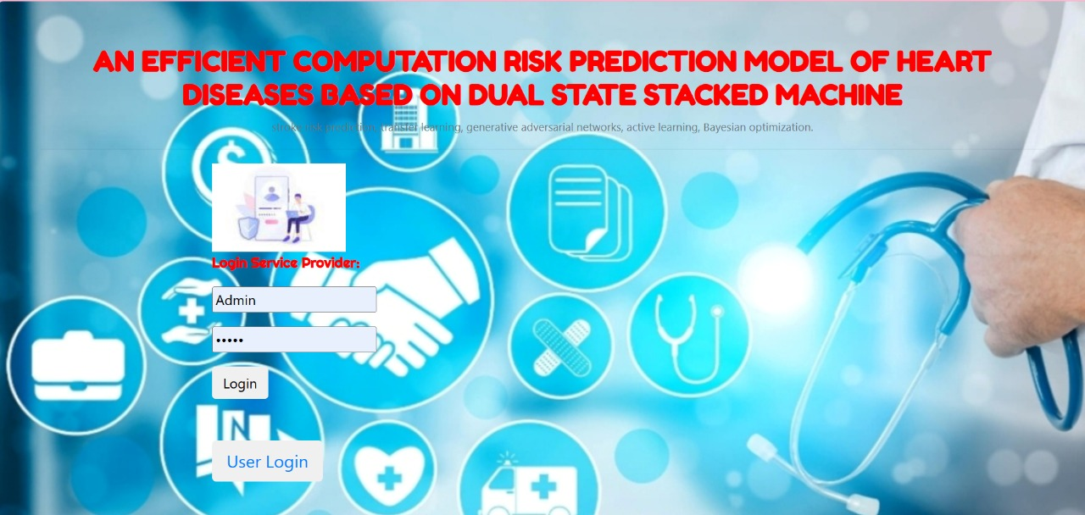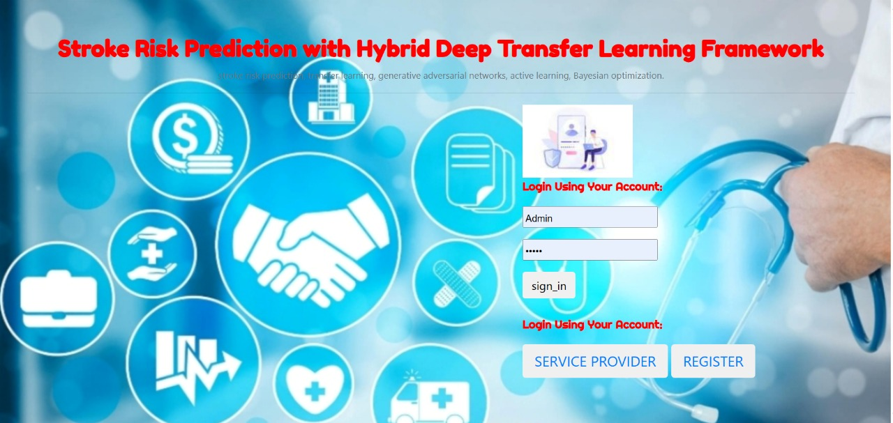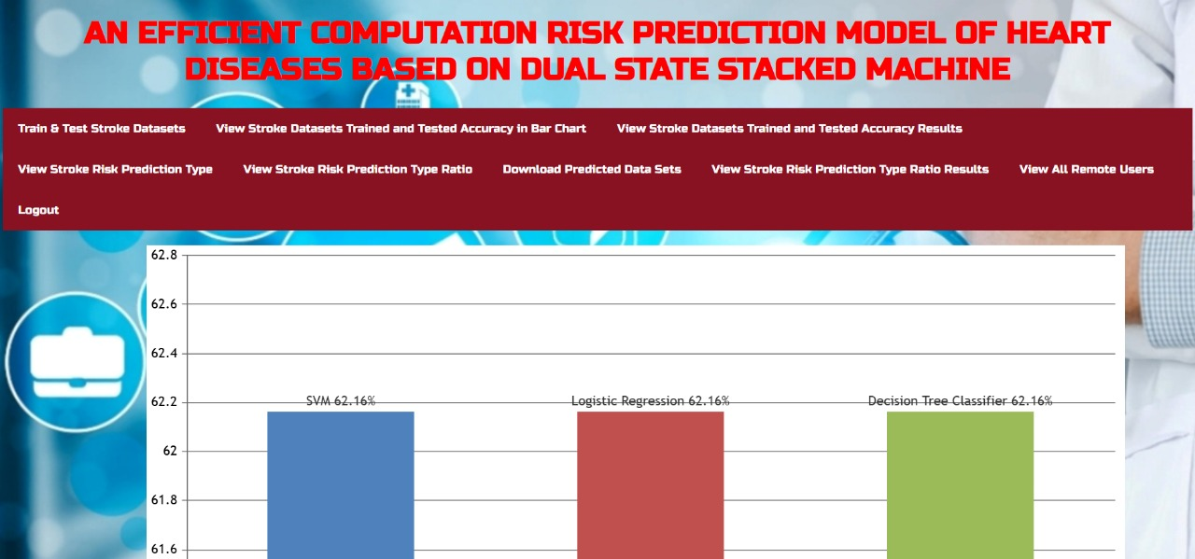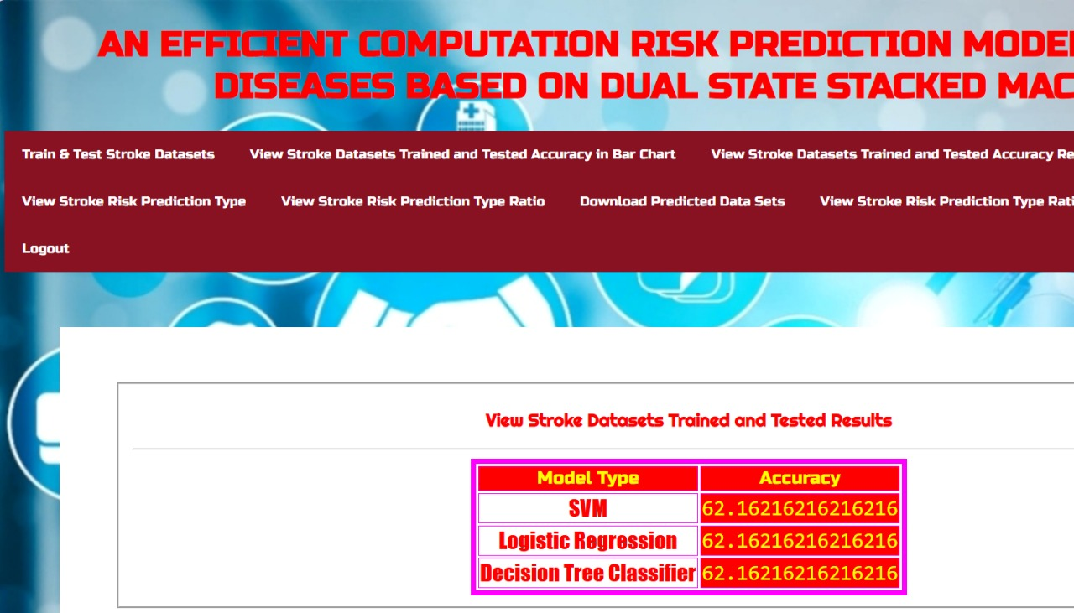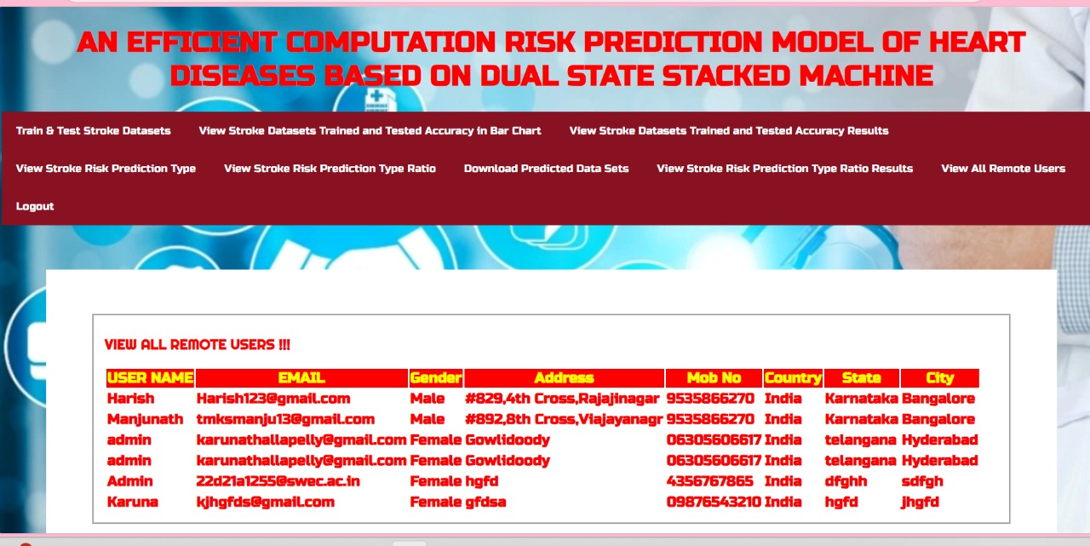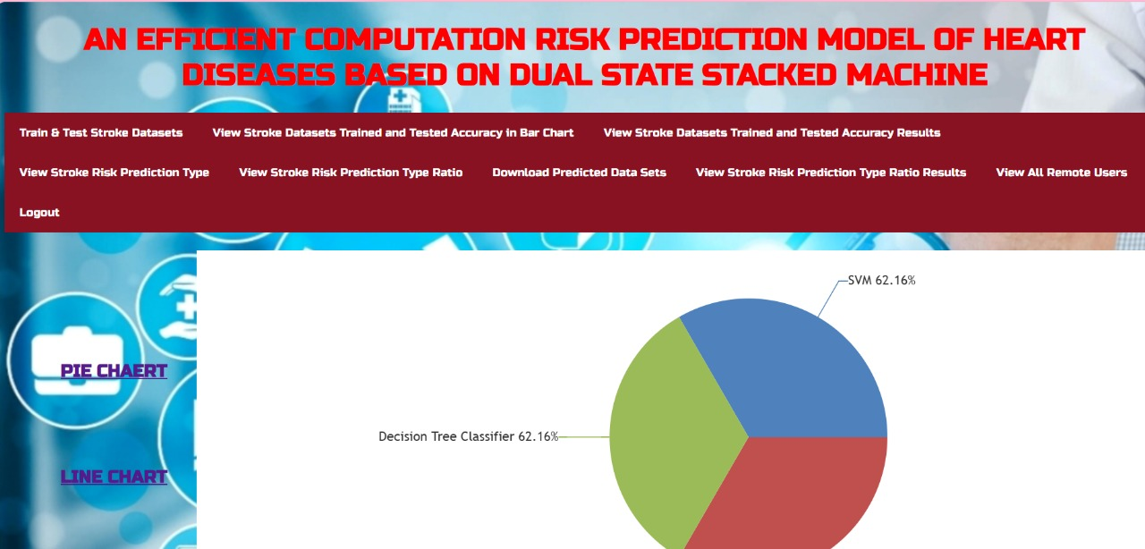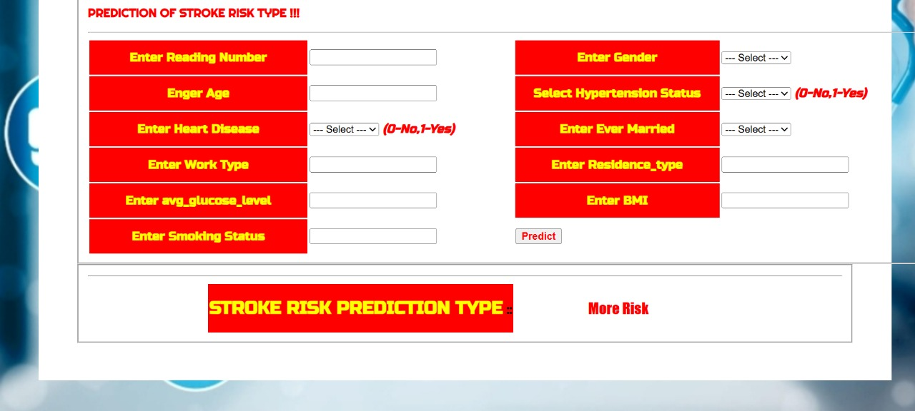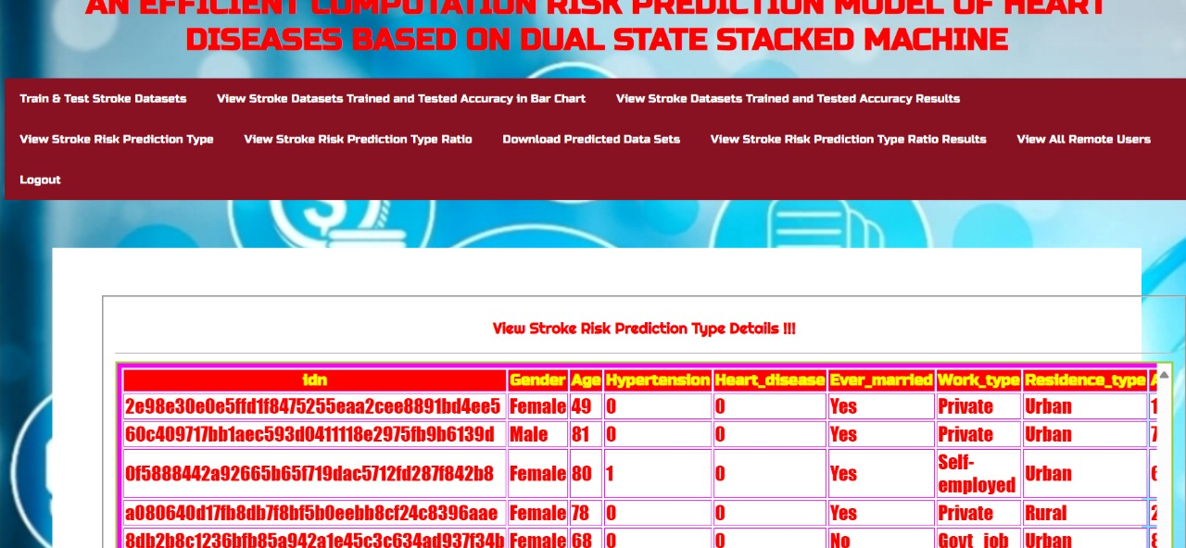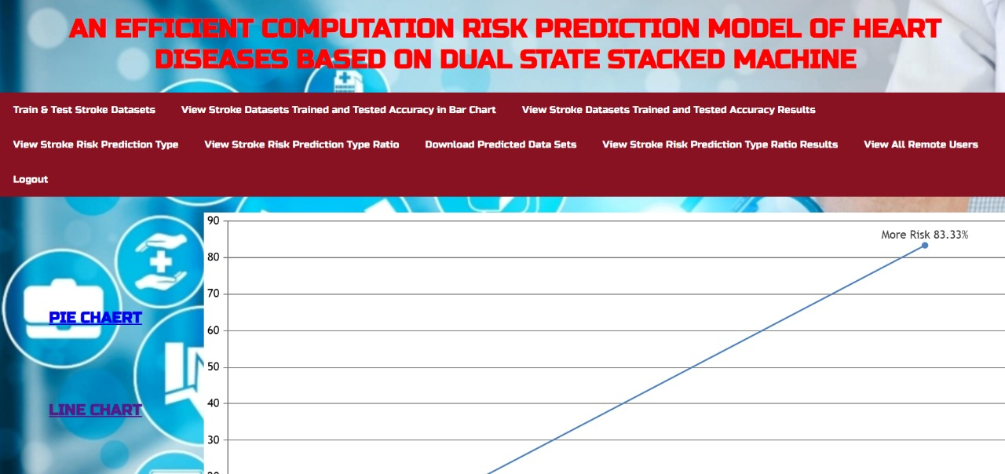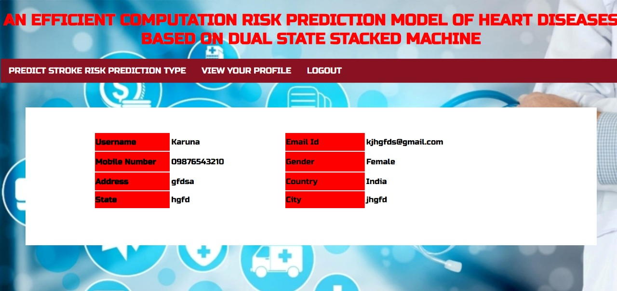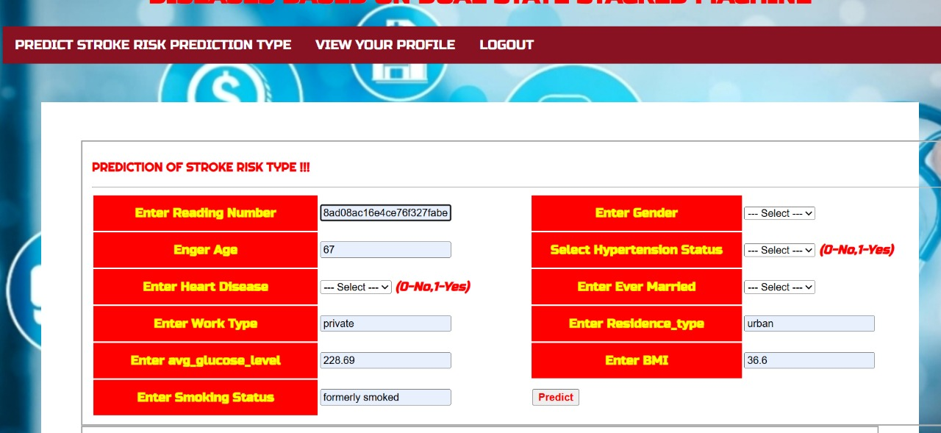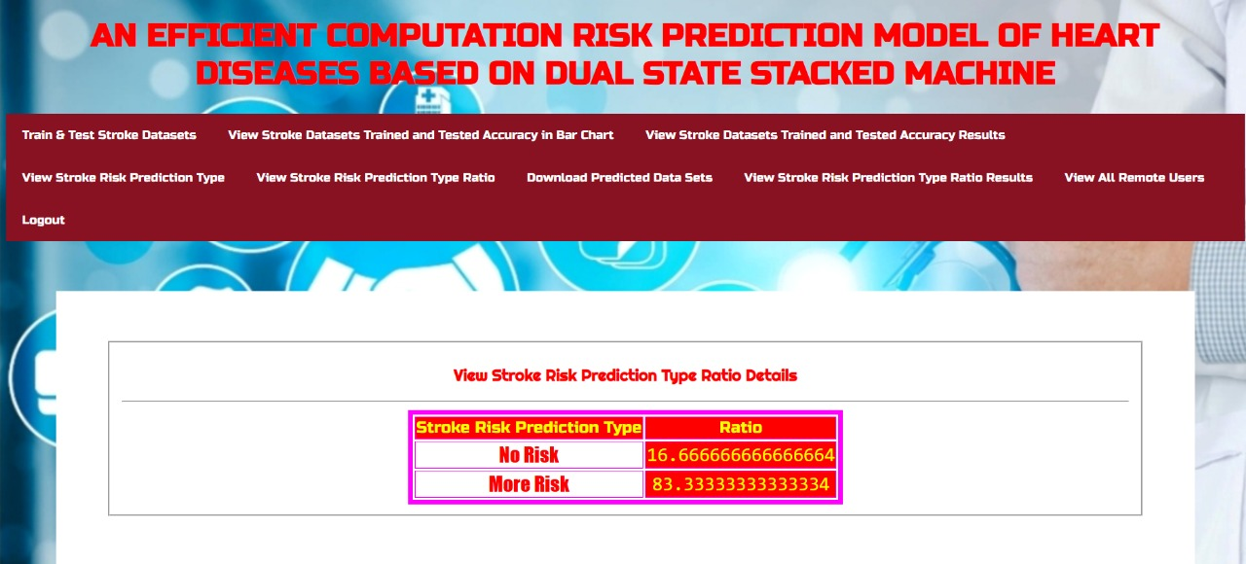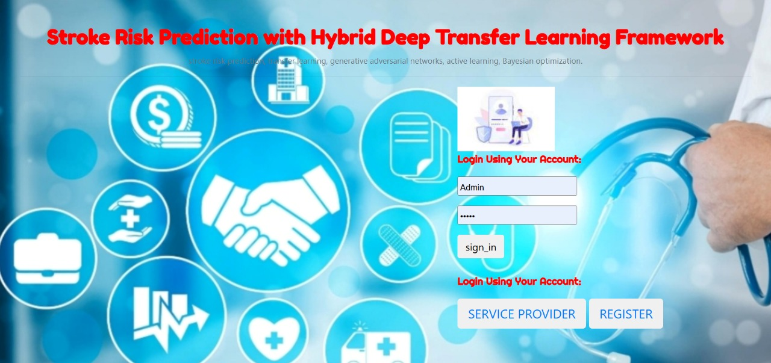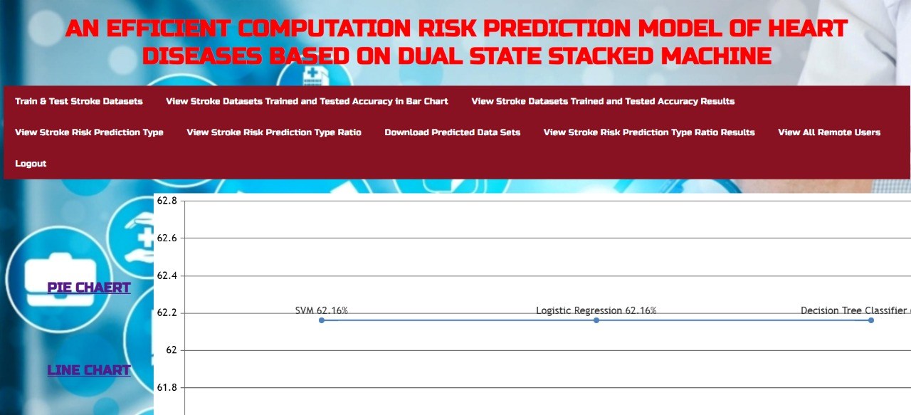

CONCLUSION & FUTURE WORK This research study concludes a two-stage stacking-based ensemble prediction model for the HD risk using three best-performing ML models: RF, DT, and XGB. The RandomizedSearchCV and GridSearchCV were used for the best parameter searching of each model, and the results of the RandomizedSearchCV of the above three deployed models were stacked to get the average accurate prediction results for the final model selection. The model’s performance creates a new benchmark with an average accuracy of 96%, which is better than the other researcher’s observable model results. The proposed model also defeats the overfitting problem with less standard deviation and uses the k-fold CV technique. The recall value is very attractive in this disease prediction model, with negligible False Negative values of 0.84% under test conditions. The outcome simulation results will work effectively on resource-constrained devices in the case of lower dataset instances because disease detection has a limitation on input data. The other low-resource dataset demonstrates the prediction model’s stability and robustness, with an excellent accuracy of 96.88% and a low standard deviation for the proposed HD risk prediction model. This research study will be further extended with feature selection algorithms and deployed on reduced features to reach a new milestone finding. Also, a deep learning-based ANN model can be incorporated to compare with these findings, and a more generalized model should be proposed using the larger instances of a dataset on the diversified domain of human disease prediction
REFERENCES
[1] D. T. Khan. Cardiovascular Diseases. World Health Organization. Accessed: Oct. 20, 2022. [Online]. Available: https://www.who.int/healthtopics/cardiovascular-diseases#tab=tab_1
[2] D. Thompson. (Feb. 2017). Heart Disease May Cost $1 Trillion Yearly By 2035. WebMD. Accessed: Oct. 20, 2022. [Online]. Available: https://www.webmd.com/heart-disease/news/20170214/heart-diseasecould-cost-us-1-trillion-per-year-by-2035-report
[3] U.S. Department of Health & Human Services. (Oct. 14, 2022). Heart Disease Facts. Accessed: Oct. 20, 2022. [Online]. Available: https://www.cdc.gov/heartdisease/facts.htm
[4] B. P. Doppala, D. Bhattacharyya, M. Janarthanan, and N. Baik, ‘‘A reliable machine intelligence model for accurate identification of cardiovascular diseases using ensemble techniques,’’ J. Healthcare Eng., vol. 2022, pp. 1–13, Mar. 2022.
[5] R. Tao, S. Zhang, X. Huang, M. Tao, J. Ma, S. Ma, C. Zhang, T. Zhang, F. Tang, J. Lu, C. Shen, and X. Xie, ‘‘Magnetocardiography-based ischemic heart disease detection and localization using machine learning methods,’’ IEEE Trans. Biomed. Eng., vol. 66, no. 6, pp. 1658–1667, Jun. 2019.
[6] M. Ozcan and S. Peker, ‘‘A classification and regression tree algorithm for heart disease modeling and prediction,’’ Healthcare Analytics, vol. 3, Nov. 2023, Art. no. 100130.
[7] M. Siddhartha. (Jun. 2020). Heart Disease Dataset (Comprehensive). IEEEDataPort. Accessed: Jul. 15, 2022. [Online]. Available: https://ieeedataport.org/open-access/heart-disease-dataset-comprehensive
[8] C. B. C. Latha and S. C. Jeeva, ‘‘Improving the accuracy of prediction of heart disease risk based on ensemble classification techniques,’’ Informat. Med. Unlocked, vol. 16, Jan. 2019, Art. no. 100203.
[9] H. A. Esfahani and M. Ghazanfari, ‘‘Cardiovascular disease detection using a new ensemble classifier,’’ in Proc. IEEE 4th Int. Conf. Knowl.-Based Eng. Innov. (KBEI), Tehran, Iran, Dec. 2017, pp. 1011–1014.
[10] R. Atallah and A. Al-Mousa, ‘‘Heart disease detection using machine learning majority voting ensemble method,’’ in Proc. 2nd Int. Conf. new Trends Comput. Sci. (ICTCS), Amman, Jordan, Oct. 2019, pp. 1–6.
[11] M. Kavitha, G. Gnaneswar, R. Dinesh, Y. R. Sai, and R. S. Suraj, ‘‘Heart disease prediction using hybrid machine learning model,’’ in Proc. 6th Int. Conf. Inventive Comput. Technol. (ICICT), Coimbatore, India, Jan. 2021, pp. 1329–1333.
[12] A. U. Haq, J. Li, J. Khan, M. H. Memon, S. Parveen, M. F. Raji, W. Akbar, T. Ahmad, S. Ullah, L. Shoista, and H. N. Monday, ‘‘Identifying the predictive capability of machine learning classifiers for designing heart disease detection system,’’ in Proc. 16th Int. Comput. Conf. Wavelet Act. Media Technol. Inf. Process., Chengdu, China, Dec. 2019, pp. 130–138.
[13] K. Yuan, L. Yang, Y. Huang, and Z. Li, ‘‘Heart disease prediction algorithm based on ensemble learning,’’ in Proc. 7th Int. Conf. Dependable Syst. Appl. (DSA), Xi’an, China, Nov. 2020, pp. 293–298.
[14] I. D. Mienye, Y. Sun, and Z. Wang, ‘‘An improved ensemble learning approach for the prediction of heart disease risk,’’ Informat. Med. Unlocked, vol. 20, Mar. 2020, Art. no. 100402.
[15] S. Asif, Y. Wenhui, Y. Tao, S. Jinhai, and H. Jin, ‘‘An ensemble machine learning method for the prediction of heart disease,’’ in Proc. 4th Int. Conf. Artif. Intell. Big Data (ICAIBD), Chengdu, China, May 2021, pp. 98–103.
[16] N. Basha and P. Venkatesh, ‘‘Early detection of heart syndrome using machine learning technique,’’ in Proc. 4th Int. Conf. Electr., Electron., Commun., Comput. Technol. Optim. Techn. (ICEECCOT), Mysuru, India, Dec. 2019, pp. 387–391.
[17] W. M. Jinjri, P. Keikhosrokiani, and N. L. Abdullah, ‘‘Machine learning algorithms for the classification of cardiovascular disease—A comparative study,’’ in Proc. Int. Conf. Inf. Technol. (ICIT), Amman, Jordan, Jul. 2021, pp. 132–138.
[18] P. Sujatha and K. Mahalakshmi, ‘‘Performance evaluation of supervised machine learning algorithms in prediction of heart disease,’’ in Proc. IEEE Int. Conf. Innov. Technol. (INOCON), Bangluru, India, Nov. 2020, pp. 1–7.
[19] K. Battula, R. Durgadinesh, K. Suryapratap, and G. Vinaykumar, ‘‘Use of machine learning techniques in the prediction of heart disease,’’ in Proc. Int. Conf. Electr., Comput., Commun. Mechatronics Eng. (ICECCME), Mauritius, Mauritius, Oct. 2021, pp. 1–5.
[20] Y. Lin, ‘‘Prediction and analysis of heart disease using machine learning,’’ in Proc. IEEE Int. Conf. Robot., Autom. Artif. Intell. (RAAI), Apr. 2021, pp. 53–58

